TWIN PREGNANCY: DELIVERY AND COMPLICATIONS
Irina Markovaª*, Asen Nikolov^{b}, Peter Markov^{c}
a,b,c”Maichin dom” University Hospital of Obstetrics and Gynecology, 2 Zdrave Str
1431 Sofia, Bulgaria

ªEmail: dr_rinna@abv.bg
^{b}Email: assen_nikolov@yahoo.com
^{c}Email: p_markov@abv.bg
Abstract

The aim of this research is to find out the incidence of twin pregnancies, the time and mode of delivery, as well as delivery related complications. The study is retro- and prospective and it covers a period of 20 years ranging from 1994 to 2014. In order to evaluate the incidence of twin pregnancy, the study includes a total of 73785 births with 1791 twins from them. Detailed analysis, regarding the delivery mode and complications was made for 562 twin pregnancies. The number of twin pregnancies in 1994 was 44 and in 2014 was 151. The incidence of twins increased from 1.18% at the beginning of the observed period to 3.79% at the end of the period. In 1994, 62% of women had vaginal delivery and only 38% Caesarean section. In 2014, 82% of the twins were delivered by Caesarean section and only 18% had vaginal delivery. Gestational age at the time of delivery in dichorionic diamniotic twins was 36+4 w.g., in monochorionic biamniotic twins - 35+0 w.g. and in monochorionic monoamniotic twins - 34+6 w.g. Results show that natal complications are more common in twin pregnancies, compared to singleton pregnancies. There is a significant increase in the incidence of twin pregnancy. The average gestational age of delivery is lesser in comparison to world references. The prevalence of Caesarean section as a method of choice for the delivery of twins is similar to the world trends.
Key words: twin pregnancy; incidence; gestational age; delivery mode; complications; obstetrics.

------------------------------------------------------------------------
* Corresponding author.
E-mail address: dr_rinna@abv.bg
- Introduction
There is a significant rise in the incidence of twin pregnancies during the past years mostly due to the recent advances in ART. The significance of this problem is further emphasized by the fact that the incidence of premature delivery in twin pregnancies is higher compared to singleton pregnancies, as well as the ongoing shift in the mode of delivery towards broader indications for Cesarean section whilst vaginal delivery of twins proves to be more complicated when compared to singletons [1]. The choice of optimal gestational age for delivery has to be balanced between the risk of intrauterine fetal death which grows with the progression of the twin pregnancy opposed to the potential loss of the newborn after a premature delivery. Data shows that a quarter of the low birth weight babies (<1500 g) are born after multiple gestation pregnancies and their neonatal death rate appears to be higher, the survival rates in general are lower, the risk for long-term morbidity is elevated [1, 2, 3, 4, 5]. The mode of delivery for twin pregnancy has significantly changed during the past 20 years in Bulgaria, which correlates to the world tendencies. Today, most of the twin gestations are delivered by Cesarean section. Vaginal delivery remains the method of choice mostly in cases of cephalic presentation of the first twin and in cases of expected low birth weight or early gestational age of delivery.
- Materials and methods
The study for the estimation of the incidence of twin pregnancies is retro- and prospective and it covers a period of 20 years (1994-2014). It has been conducted in the Delivery Ward of Maichin Dom University Hospital, Sofia and it enrolls a total of 73645 deliveries, 1651 of them are twin deliveries.
The study for the evaluation of the mode, the age and the complications of twin deliveries is entirely prospective and a total of 562 twin gestations have been reviewed in detail during the period from January 2010 to March 2014 in the same hospital.
Factors for enrollment in the prospective study include:
- Twin gestation
- Gestatational age after 26 w.g.
- Birth weight above 800 g
The incidence of twin gestation for a 20 year period has been calculated. Gestational age of delivery, the mode for delivery, the indications for Caesarian section (SC), the complications of operative and normal vaginal delivery have all been evaluated in 562 twin pregnancies. A comparative analysis of 560 singleton pregnancies has been performed.
- Results and discussion
3.1 Incidence of twin pregnancy

The absolute figure of twin pregnancies in our hospital has been 44 in 1994, with a median value amid 40-60 for the next following years. Since 2006 there has been an abrupt rise in the incidence which reached 150 twin pregnancies in 2012, 132 in 2013 and 151 twin pregnancies in 2014. Table 1 shows these changes.
Table 1: Incidence of twin pregnancies from 1994 to 2014 in “Maichin dom” University Hospital (number)
Year | All deliveries | Twin pregnancy deliveries
1994 | 3727 | 44
1995 | 3518 | 37
1996 | 3234 | 44
1997 | 2987 | 36
1998 | 3081 | 50
1999 | 3701 | 54
2000 | 3698 | 50
2001 | 2733 | 58
2002 | 2889 | 54
2003 | 3151 | 51
2004 | 3142 | 42
2005 | 2972 | 49
2006 | 2796 | 77
2007 | 2668 | 80
2008 | 3021 | 95
2009 | 3844 | 139
2010 | 3570 | 140
2011 | 3427 | 118
2012 | 3975 | 150
2013 | 3842 | 132
2014 | 3978 | 151

Results show that the incidence of twin pregnancy rises from 1.18% in 1994 to 3.65% in 2015. This is almost a 3-fold rise in the incidence and it is graphically presented in fig. 1
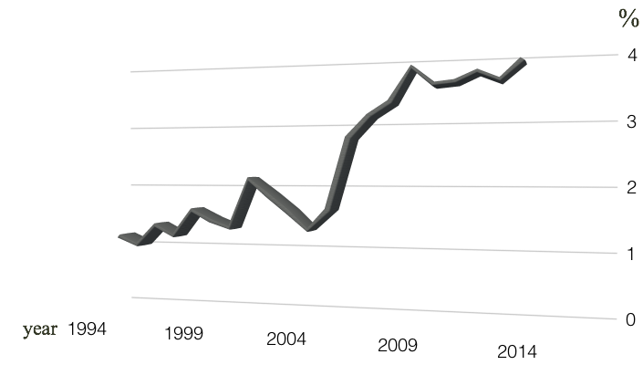
Figure 1: Incidence of twin pregnancy deliveries to all the deliveries in “ Maichin dom” University Hospital (percent)
The recent data regarding the incidence of twin gestation in Bulgaria, according to the National Statistical Institute in 2014 shows that there are 834 twin deliveries from a total of 62539 deliveries for the whole country, which is 1.3%. Results from our study demonstrate almost twice as high value for the incidence in 2014. This is easily explained by the fact that there is a concentration of a major part of the high-risk pregnancies in “Maichin Dom” University Hospital, Sofia for the region or the country as a whole. More significant appears to be the general tendency for the rise of the twin gestation incidence in our hospital and in the country as a whole. Data from our hospital correlates with data from USA, which shows a 3.4% incidence of twin pregnancies in 2013 [6].
3.2 Timing of delivery
562 ladies with twin gestation have been divided into three groups:
- dichorionic diamniotic (DCDA) – 494 ladies
- monochorionic diamniotic (MCDA) – 61 ladies
- monochorionic monoamniotic (MCMA) – 7 ladies
A mean gestational age for delivery is 36+4 w.g. for DCDA, which is earlier in comparison to world references. The explanation for this result is that there is a predominance of the SC mode of delivery at earlier gestational age in recent years and that obstetricians want to reduce the potential fetal risks related with the prolongation of the twin pregnancy towards the term itself. It is generally accepted that elective delivery before 38 w.g. is not recommended although most protocols show no evidence backing up the optimal gestational age for delivery in DCDA [7].

Mean gestational age for delivery in MCDA is 35+0 w.g. This group enrolls a total of 61 ladies, 1/10 of which are pregnancies complicated by FFTS and another 1/10 are complicated by intrauterine growth retardation. These are the main considerations related with the earlier gestational age for delivery compared to world trends.
MCMA are delivered averagely in 34+6 w.g. All of the 7 patients have been hospitalized for a long period before the delivery, with daily fetal monitoring and numerous US examinations which allowed for the maximum postponement of their delivery, which is actually at a later stage in comparison to the world references [8].
Most authors recommend gestational age for delivery in DCDA twins to be after 38 w.g., in MCDA twins between 37-38 w.g. and for MCMA twins – after 34 w.g. [9, 10, 11, 12].
This data is shown on fig. 2
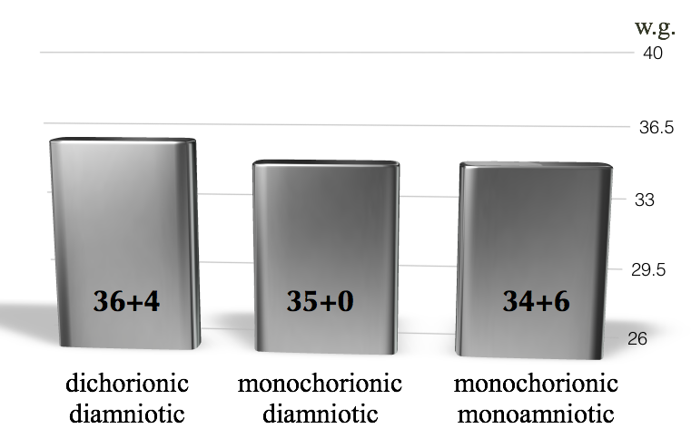
Figure 2: Time of delivery in “ Maichin dom” University Hospital
3.3 Mode of delivery
The mode of delivery in twin gestations has been significantly changed during the past two decades. In 1994, 62% of the ladies with twin pregnancy have had a normal vaginal delivery, with only 38% of SC. In 2014, there is an opposite mirror image – 82% are delivered by SC and only 18% have had a vaginal delivery. Results are shown on fig. 3.
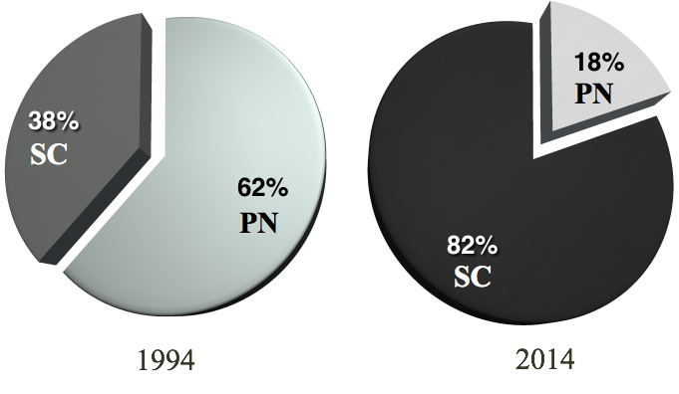
Figure 3: Mode of delivery in “ Maichin dom” University Hospital
Fig. 4 graphically presents the tendency of the modes for delivery in twin gestations during the years. In the beginning of the researched period, SC has been used in approx. 40%, in 2004 it reached 90%, but in recent years there is an average SC constant around 80%. In 2013, 74% of the ladies with twin gestation have been delivered by SC in USA [6].
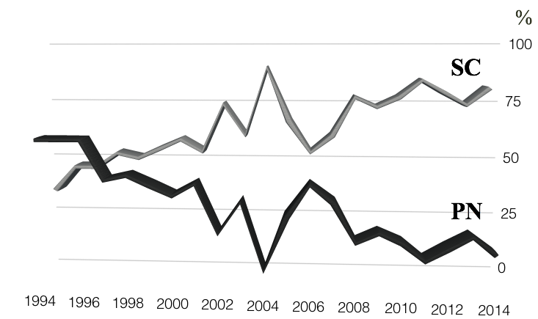
Figure 4: Trend of delivery mode in University Hospital “ Maichin dom”
- Vaginal delivery

Many countries suggest a trend for going back to vaginal delivery in twin gestations. Some authors even consider that vaginal delivery can be safe in specific and exactly diagnosed cases of monochorionic monoamniotic twins [13, 14].
In our study, 110 women (19.5%) of the total 562 ladies with twin gestation have had a vaginal delivery. There is a statistically significant correlation between the mode of delivery and the twins’ fetal presentation in utero. In 48% of the women with vaginal delivery, both fetuses were with cephalic presentation. First twin in cephalic presentation and second twin with breech presentation were delivered vaginally in 24%. In 5% of the cases, there is breech presentation of the first twin and cephalic presentation of the second. In 1.8% of the cases, both twins were in breech presentation. Also in 1.8% there was cephalic presentation of the first twin, followed by manual extraction of the second twin. Chervenak and coauthors observe almost the same distribution of the fetal presentations in vaginal delivery of twin pregnancies [15].
Our research shows that there is a statistically significant relationship between the vaginal delivery as a mode of parturition in twin pregnancy and the history of previous normal vaginal deliveries for the same patient. This has been confirmed by Israeli authors [16]. Vaginal delivery of twins is more frequently chosen for ladies who have had one or more previous vaginal deliveries in the past. Only 77 (17.5%) of the nulliparous ladies with twin gestation have had vaginal delivery. 24 (22%) of the multiparous women with one previous vaginal delivery have had another vaginal delivery of their twin pregnancy and 5 (41%) ladies with two previous vaginal deliveries have had a third vaginal delivery of twins. These results are shown on fig. 5.
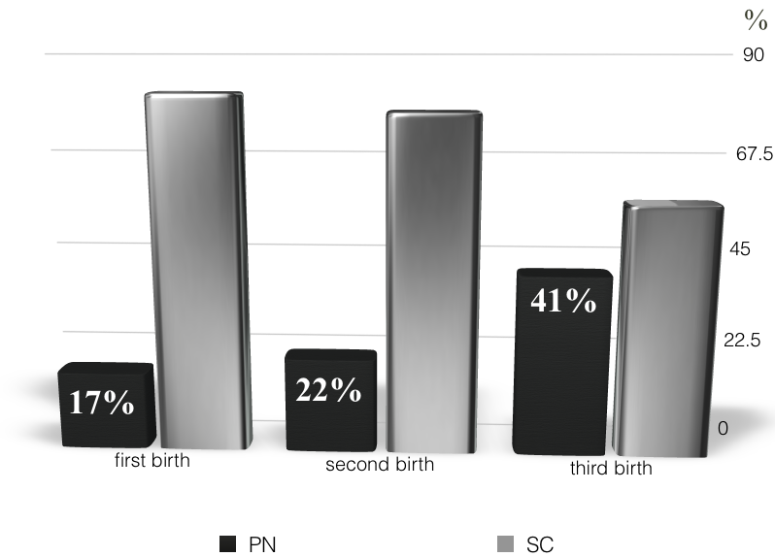
Figure 5: Vaginal delivery and parity
The interval between the delivery of the first and the second twin has been evaluated, in most cases approx. 5 minutes. The longest period was 24 min and the shortest – 1 min. In 2008, Ravishankar and co. suggest that the time interval between the delivery of the first and the second twin is of lesser significance for the neonatal status of the second twin, because of the contemporary methods for fetal monitoring and ultrasound diagnostic information [17].
Mean blood loss the for vaginal delivery of twins was found to be 250 ml.

- Caesarian section
452 women from a total of 562 were delivered by SC, which equals to 80.5%.
The indications for Caesarian delivery are divided into two main groups:
I-st group: indications, related to the twin pregnancy:
  - All cases in which twin fetuses are not in cephalic/cephalic or cephalic/breech presentation [18]
  - All cases in which first twin is smaller than the second
  - Monoamniotic pregnancies
II-nd group: indications, related to pathology of the mother or the fetus – all of which correspond to Caesarian delivery in singleton pregnancies.
The most frequently used indications for SC of twins in our study are: non-cephalic presentation of the first twin, status post SC, sterility, preeclampsia, IVF and age of the patient. This data was compared to another research of 22000 women with twin gestation in the Netherlands regarding the indications for urgent and elective Caesarian section. Their results are similar as follows: non-cephalic presentation of the first twin, previous C-section, nulliparity, patient age and preeclampsia [19].
Regional (spinal) anesthesia was used in 97% of the cases of Caesarian delivery of twin gestation in our study, while general (endotracheal) anesthesia was used in 2.4%, and only 0.4% of the cases had combined epidural with endotracheal anesthesia. Spinal anesthesia for C-section is well accepted in our practice with a level of proven effectiveness and a common lack of complications [1].
Evaluation of the different skin incisions for the C-section used in our hospital has also been performed. Most widely used is the Pfannenstiel incision (98.9%). A low midline incision was used in selected cases when there was Placenta praevia totalis, clinical or ultrasound markers for silent uterine rupture, HELLP syndrome or prolapse of the umbilical cord.
A comparison of the incisions of the uterine wall is also presented. Isthmicotransverse incision of the uterus was chosen in 97.2% of the C-sections. Isthmicolongitudinal incision was used in all cases with a low midline incision, or in cases with early gestational age of twin pregnancy: 1 patient in 26 w.g., 1 patient in 27 w.g. and 3 patients in 28 w.g., as well as in selected patients with elective myomectomy during the Caesarian section.
Mean blood loss during the Caesarian delivery of twins is 500 ml. The biggest blood loss was 1300 ml in a patient after IVF, nulliparous in 28 w.g., with no history of previous disease. This was a case of urgent C-section with Pfannestiel skin incision and isthmicotransverse incision of the uterus.
3.4 Delivery complications

Results show that there are more complications after vaginal delivery of twin pregnancy compared to singleton pregnancy. The incidence of episiotomy, perineal ruptures and cervix lacerations in singleton and twin deliveries has been evaluated. The mediolateral episiotomy is more frequently used in twins’ vaginal delivery – 37% of the cases, while only 24.5% of the singleton parturitions had episiotomy. Perineal ruptures were divided in 4 groups and data shows that I-st grade ruptures are found in 14% of the women with twin delivery and only 8% of singleton deliveries. Cervix lacerations in twin delivery were 11.4%, whilst for singleton deliveries the percentage was 9.8%. These results are shown on fig. 6.

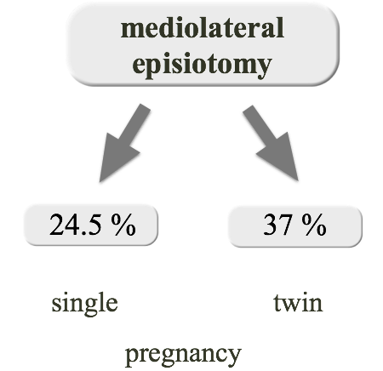 | 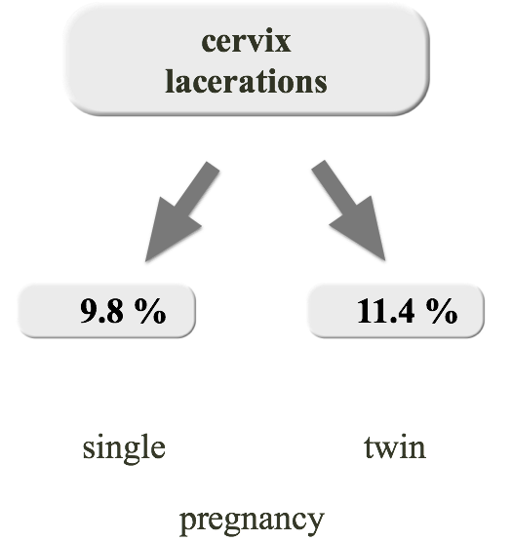 | 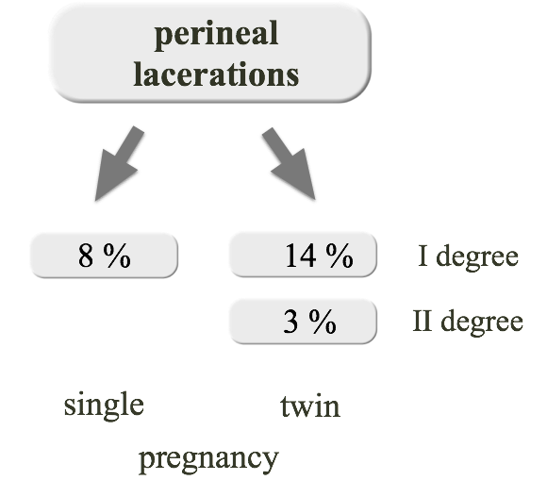
Figure 6: PN complications
Complications after C-section of twins were: 2 cases of uterine subatony, 1 case of uterine atony, subfascial and subcutaneous hematoma, uterine incision dehiscence, uterine rupture. The rupture of the uterus was a circular rupture of the posterior uterine wall in a patient with a vaginal pessary placed in 19 w.g., the C-section was performed in 28+5 w.g. Two of the patients had myomectomy during the Caesarian section and 12 patients required hemotransfusion. Table 2 describes these complications:
Table 2: SC complications
Type of SC complications | Number of cases
Uterine subatony | 2
Uterine atony | 1
Subfascial hematoma | 1
Subcutaneous hematoma | 1
Uterine dehiscence | 1
Uterine rupture | 1

- Conclusions
The last two decades reveal a two- to threefold increase in the incidence of twin gestation in Bulgaria. Gestational age for delivery of twin pregnancies in our hospital is lesser compared to world references. C-section is the method of choice for the delivery of twin gestations. There are more delivery associated complications of twin gestations compared to singleton parturitions both for the vaginal mode of delivery as well as for the Caesarian section.

References
[1] Asen Nikolov. “Gestational age, place and mode of delivery in twin pregnancies” Akush. Ginekol. 2011, 2, 23-30
[2] Nikola Vasilev. “Multiple Gestation”. Obstetrics, edited A. Hadjiev, Yarakov A, Vasilev N. MI “ARKO”,1998, 79-89
[3] JM Dodd, Crowther. “Evidence-based care of women with a multiple pregnancy”. Best Pract Res Clin Obstet Gynaecol. 2005 Feb;19(1):131-53
[4] Keith LG, Papiernik E, Keith DM, Luke B: Multiple Pregnancy: Epidemiology, Gestation and Perinatal Outcome. London, Parthenon Publishing Group, 1995
[5] L Keith, Johnson, T, Glob. libr. women's med. (ISSN: 1756-2228) 2008; DOI 10.3843/GLOWM.10140
[6] ZH Bateni, Clark SL, Sangi-Haghpeykar, Aagaard KM, Blumenfeld YJ, Ramin SM et al. “Trends in the delivery route of twin pregnancies in the United States, 2006-2013”. Eur J Obstet Gynecol Reprod Biol. 2016 oct; 205: 120-6
[7] АCOG Practice Bulletin #56: Multiple gestation: complicated twin, triplet and high-order multifetal pregnancy. Obstet Gynecol 2004 Oct; 104(4): 869-83
[8] P. Steer. “Perinatal death in twins”. BMJ 2007 March; 334: 545
[9] K. Barrett, Robinson, Russell S. Miller, Mary E. D’Alton, William A. Grobman. “Effectiveness of timing strategies for delivery of monochorionic diamniotic twins”. American Journal of Obstetrics and Gynecology. July 2012, Volume 207, Issue 1, Pages 53.e1-57.e7
[10] Jennifer L. Burgess, Elizabeth R. Unal, Paul J. Nietert, Roger B. Newman. “Risk of late preterm stillbirth and neonatal morbidity for monochorionic and dichorionic twins”. Am J Obstet Gynecol. 2014 Jun; 210(6): 578.e1-578.e9
[11] Amy Elizabeth Sullivan, Paul Nathan Hopkins, Hsin-Yi Weng, Erick Henry, Jamie Oi-Ting Lo, Michael Walter Varner et al. “Delivery of monochorionic twins in the absence of complications: analysis of neonatal outcomes and costs”. Am J Obst Gyn, 206, 3, March 2012, 257.e1-257.e7
[12] Roger B. Newman, Elizabeth R. Unal. “Multiple gestations: timing of indicated late preterm and early-term births in uncomplicated dichoriotic, monochoriotic and monoamniotic twins”. Seminars in perinatology, 35, 5, Oct 2011, 277-285
[13] M. Khandelwal, Revanasiddappa VB, Moreno SC, Simpinks G, Weiner S, Westover T. “Monoamniotic Monochorionic Twins – can they be delivered safely via vaginal route?” Obstet Gynecol 2016 May; 127 Suppl 1:3
[14] O Anselem, Mephon A, Le Ray C, Marcellin L, Cabrol D, Goffnet F. “Continued pregnancy and vaginal delivery after 32 weeks of gestation for monoamniotic twins”. Obstet Gynecol Reprod Biol. 2015 Nov; 194: 194-8
[15] FA Chervenak, Johnson RE, Youcha S, Hobbins JC, Berkowitz RL: “Intrapartum management of twin gestation”. Obstet Gynecol 1985;65: I 79-124
[16] H de Castro, Haas J, Schiff E, Sivan E, Yinon Y, Barzilay E. “Trial of labour in twin pregnancy: a retrospective cohort study”. BJOG. 2016 May; 123(6): 940-5
[17] V Ravishankar, Gerald Quirc J. “Multiple Gestation”. Operative Obstetrics edited by JP O”Grady and ML Glimovsky. Cambridge university press 2008. 322-347
[18] I Blickstein, Goldman RD, Kupferminc M. “Delivery of breech first twins: a multicenter retrospective study”. Obstet Gynecol 2000 Jan;95(1):37-42
[19] SM Goossens, Hukkelhoven CW, de Vries L, Mol BW, Nijhuis JG, Roumen FJ. “Clinical indicators associated with the mode of twin delivery: an analysis of 22,712 twin pairs”. Eur J Obstet Gynecol Reprod Biol. 2015 Dec; 195: 133-40

