**Strengthening The Efficiency of Orphan and Vulnerable Children Program Design and Implementation through Geospatial application in Nigeria**

Williams Ojoa\*, ADEGOKE Olufemib, AGWU Ibiamc, UDUMA Emed, BALONWU Luciae, MADUEKE Leilaf

Affiliations: a\* Geography and Ecosystem, Lund University, Sölvegatan 12, SE-223 62 Lund, Sweden,

b,e,f Pact, 16,Mafemi Crescent, Abuja, Nigeria, c,d Safe Motherhood Ladies Association,

*aEmail:* [*williamojo@gmail.com*](mailto:williamojo@gmail.com)

**Abstract**

Geographic Information Systems (GIS) as a tool to strengthened program coordination and scale-up of Orphan and Vulnerable Children (OVC) related services in resource-limited settings remains largely untapped. Assessing geographic program coverage in its focus communities, Pact Nigeria in partnership with an indigenous community based organization, Safe Motherhood Ladies Association (SMLAS) implemented a GIS study in 8 communities across 3 Local Government Areas (LGA) of Ebonyi State. Although conventionally used in the context of vertical programs, GIS approaches can help improve service delivery outlets, extent of effective coverage and beneficiaries. About 450 children enrolled in the OVC program, were geotagged with attributes of service providers offering health, nutrition, shelter, economic strengthening, education, child-protection, legal and psycho-social support (services required in the OVC continuum of care), the geotagged ID were then linked to database containing demographics and relevant service assessment information. In-depth spatial analysis of this information led to the identification of geographic features of interest and the mapping of household, OVC’s corresponding service providers/volunteers and their proximity to service outlets. The resultant effect being improved accessibility to relevant services and more effective OVC programming in the 3 focal communities. This study highlights the importance of a GIS approach as a decision-aiding tool for programmatic interventions. Its’ forte lies in its capability for increasing the efficiency of scarce program resources. As a result, Pact Nigeria plans to scale-up this GIS innovation across all its supported Community Based Organizations (CBO) implementing OVC programs across 4 states in Nigeria.

***Keywords:*** Community Based Organizations; Geographic Information System; Global Positioning System; and Local Government Areas; Orphan and Vulnerable Children.

------------------------------------------------------------------------

\* Corresponding author.

E-mail address: williamojo@gmail.com.

Paper style is not standard for the journal; it should be exactly according to the template.

1. Introduction

In Nigeria, Africa’s most populous country, the National Situation Assessment and Analysis on OVC in Nigeria [4] indicates that there is an estimated 17.5 million Orphans and Vulnerable Children (OVC) in the country [8]. This phenomenon has brought a lot of challenges to children, parents, communities and governments in the country. Some of the undesired consequences, of the dire situation is that OVC are more likely to be involved with deviant peer groups that can seriously endanger successful transition into mainstream adulthood. Educationally, OVC suffer from high rates of school failure, high school dropout, and incarceration. In addition, OVC are likely to experience prejudice, and cultural intolerance that alienate them and make them withdraw or rebel against mainstream society and conventional social institutions.

According to the OVC National Plan of Action,a child is defined as a boy or girl below 18 years of age and an orphan is any child who has lost one or both parents, irrespective of the cause of death[4,7]. Though the definition of vulnerability varies from society to society, in the context of OVC programming in Nigeria, a child is said to be vulnerable if because of circumstance of birth or immediate environment, he or she is prone to abuse or deprivation of basic needs, care and protection and thus disadvantaged relative to his or her peers [5].

The Federal Government of Nigeria (FGN) committed response to the increasing trend and plight of OVC was the establishment of the OVC unit in the Federal Ministry of Women Affairs and Social Development (FMWA&SD) charged with the responsibility of coordinating the National response to the OVC phenomenon. In addition, the government embarked on a National Plan of Action (NPA) on OVC to provide a framework for accelerating the responses to OVC, and build on previous and existing experiences to reach more children with sustainable basic services.

The Rapid and Effective Action Combating HIV/AIDS in Nigeria (REACH Nigeria) funded by the US President’s Emergency Plan for AIDS Relief (PEPFAR) through the US Agency for International Development (USAID) implemented by Pact Nigeria is working to support the Federal Government of Nigeria’s effort to scale up care and support services for Orphan and Vulnerable Children (OVC).

1. Materials and Method

*2.2. Study Location*

Ebonyi State is one of thirty-six states in the Nigeria (Fig.1). It is located in south-eastern, [Nigeria](http://en.wikipedia.org/wiki/Nigeria), with a population of 2,176,947 inhabitants and estimates 1,132,517 children aged 0-18 years [8]. According to the Ebonyi state prevalence published in the National Situation Assessment and Analysis on OVC, there is an estimated 155,187 OVC in the state [6]

**Figure 1:** Map of Nigeria Showing Ebonyi State



The tremendous potential of Geographic Information System (GIS) to benefit public health care services delivery cannot be overemphasized. GIS is potentially supportive in all areas of public health programming, and research, in the description and explanation of spatial variationin disease patterns and other health related conditions or the planning and use of public health services [7].

REACH Nigeria Project recognizing this untapped potential and the need to improve the efficiency of OVC programs, whilst assessing geographic program coverage in its focus communities, REACH Nigeria in partnership with an indigenous community based organization, Safe Motherhood Ladies Association (SMLAS) implemented a GIS study of its OVC program in focus communities across 3 Local Government Areas(LGA) as shown in (Fig.2) of Ebonyi State.

**Figure 2:**Map of Ebonyi State Showing Focus LGAs

LGAovc

***2.21. Desk review***

According to Christian, the identified that demand pressure seems to be the reason why gaps exist in some area over others for those seeking treatment for substance abuse usage. Computing for distance to Health Center (HC) was noted as a gap in health accessibility. Results thus identified hotspots for low-income and racial minority individuals in contrast with the spatial accessibility. So, a better comprehension of the service coverage among low-income and minority communities was revealed with the GIS tool. Clearly showing that low income and minority have disadvantages to access substance abuse treatment HC in the Dallas-Fort Worth metroplex area [1].

Similarly, Mahler in his work used GIS tool to scale up and reach 264,990 males aged 10-33 years with a voluntary medical male circumcision (VMMC) over 5 years in two regions of Tanzania.This ambitious strategy seeks to use innovative ways in areas that has the highest HIV and lowest circumcision prevalence. It describes the strategy to ensure effective VMMC, i.e. reducing female-to-male HIV transmission by Tanzania's Ministry of Health and Social Welfare (MOHSW).Plans were under way to even use mobile team to set up temporary HC to reach lesser-served areas with VMMC. So in 2012, MOHSW began using geographic information systems (GIS) to strategically plan the location of outreach campaigns [8].

This instantly showed gaps and need, thus digitized map layers created served as decision-making tools, informing where the mobile VMMC outreach need to be temporary located. This paper cores analysis was accessibility to Health Centers (HC) and its association to other dimensions of population seeking HC services. It tries to understand how strong is the association between General Practitioner (GP) services, hospital infrastructure against the population's health status, owning a car and distance influences decision to visit the hospital [2].

**2.3. Methodology**

Pact Nigeria in collaboration with SMLAS carried out training on the use of the GPS devices to record coordinates/waypoint (i.e. location) data for the data collectors to ensure that standard procedure for accurate coordinates was followed.

In addition, GPS coordinates of the service provider/volunteer and other relevant significant locations were also collected to determine proximity of the children to service outlets and service providers. Coordinates and attributes of service outlets offering health, nutrition, shelter, economic strengthening, education, child-protection, legal and psycho-social supports (services required in the OVC continuum of care). In addition, coordinates of each child were then mapped to an existing database containing demographics and relevant service assessment information on the children.

The GPS coordinates collected were transformed for uniformity and entered into excel sheet and imported into ArcGIS 10.1 software [3]. In the ArcMap application, the attribute data including location coordinates were imported into ArcMap, using join and relate options to overlay the points with the LGA shapefiles and imported into ESRI Arcmap for spatial analysis, additional population and estimated number of children needing OVC support services was also added as overlay from Nation Population Census and National Situation Assessment and Analysis on OVC [3,9].

Taking cognize that this study is not without limitation, amongst them was the fact that it does not cover some neighboring LGA and thus where exist any CSO or volunteer located in the area this research study was not able to consider such data, Another observe limitation was the fact that volunteers turnover was very high, so this can easily created skewed in the analysis, as we noticed some of them dropped off even during this study.

1. Results

This study led to the development of a geo-spatial database and resultant spatial maps which present relevant spatial attribute data of the respective program’s focal communities. Presented in this section are the salient findings.

**Figure 3:** Map of Ebonyi State showing proportion of OVC across the Local Government Areas.



Figure 3 above shows the distribution of OVC across all LGAs in Ebonyi state. The distribution of proportion of OVC was lowest in Ishielu LGA and highest in Afikpo North LGA. This spatial information is very useful for state level policy makers, programmer and implementer in ensuring equitable allocation of resources based on the distribution of the burden across the state. This information was generated using Nation Population Census and National Situation Assessment and Analysis on OVC prevalence rates across the state.

This study did not investigate how resources for OVC programming are currently deployed in the state, but such findings if displayed spatially could also enable both programmers and policy makers to improve resource allocation. In addition, further investigations could also look into distribution of number of organizations working in the respective LGAs in the state. This information when generated would help state level coordinators (State Ministry of Women Affairs) to better coordinate and align organizations to respective LGAs, if such LGAs are currently served by other organizations. The findings of the data coordinates collected from the 450 OVC enrolled in the program are presented in (Fig.4) below.

**Figure 4:** Map of Ebonyi State Showing Spatial Distribution of OVC services across the focus LGA

OVC_kidpoint

Figure 4 above shows how the OVC enrollment were distributed across the 3 LGAs. There were 147 OVC, 155 OVC, and 148 OVC enrolled in Ohaukwu LGA, Abakaliki LGA, and Ezza South LGA respectively. The OVC were extensively distributed across the 3 LGAs. This spatial information provides the coverage of enrolled children across the LGA.

This information is useful to infer that the proximity of the OVC enrolled across the LGAs and would help programmers to determine the level of effort required to serve all the children. From the data we see that the OVC are sparsely distributed within all the local government. Such information could help determine man power and resources required for the program. Since most OVC programs depend largely on service providers/volunteers, it is important to use GIS spatial information to inform service provider/volunteer OVC assignment.

**Figure 5:** Map of Ebonyi State Showing Distribution of service providers/volunteers and OVC services across the focus LGAs



The study carried out an in-depth spatial analysis of GPS coordinates of the program service providers/volunteers who are assigned to a number of OVC and are responsible for their service provision. There were a number of interesting findings from the spatial map generated showing the service provider/volunteer and OVC distribution.

There were 14 service providers/volunteers caring for 147 OVC in Ohaukwu LGA, 13 service providers/volunteers caring for 155 OVC in Abakaliki LGA and 11 service providers/volunteers caring for 148 OVC Ezza South LGA. Interestingly, figure 5 shows the distribution of the OVC and service provider/volunteer. We find from the spatial presentation of the data a cluster of service providers/volunteers concentrated in one part of the LGA to cover OVC that are dispersed across the LGA, spatial analysis shows the most apparent in Ezza South LGA.

Having the service provider/volunteer in close proximity to the OVC enrolled has positive implication on the program. As it would ensure that the OVC are contacted more frequently with minimal efforts. Such information is useful to improve the efficiency and effectiveness of the OVC program.

The assignment of OVC to respective service providers/volunteers is very crucial for the success of an OVC program. This study took a closer look into the assignment OVC to respective service providers/volunteers and the distribution to better appreciate the current dynamics and inform the OVC program. Figure 6 shows an illustration of 2 selected service providers/volunteers identified by V12 with blue star and V13 with red star in the map. From figure 6 shows that V12 is assigned 18 OVC under his care while V13 is assigned 5 OVC. In addition to this disproportionate burden of OVC across the 2 service providers/volunteers, the lack of coordination of catchment area for each OVC is also demonstrated. This information indicates that the catchment or sharing of OVC needs to be re-organized to allow for strategic arrangement of service providers/volunteers. From the figure, at least 3 OVC covered by V13 needs to be re-assign to V12 for ease of coverage and about 7 of OVC covered by V12 needs to be transferred to V13.

**Figure 6:** Map Showing Spatial Distribution of service provider/volunteer and OVC assigned in Ezza South LGA

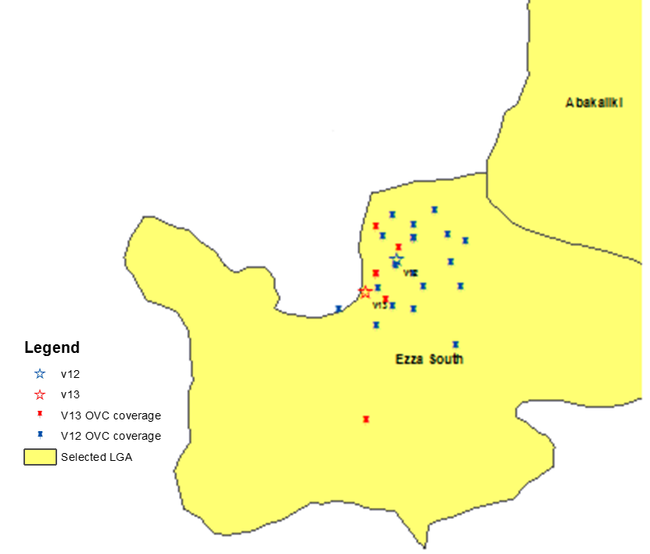

1. Conclusion

The study showcases the potential of Geographic Information System (GIS) in OVC program delivery particularly in resource-poor settings. This served as a tool for optimal decision making on service provision and coordination of the OVC program; the resultant effect being improved accessibility to relevant services and more effective OVC programming in the 3 focal communities. This study highlights the importance of a GIS approach as a decision-aiding tool for programmatic interventions. Its’ forte lies in its capacity for increasing the efficiency of scarce program resources. As a result, Pact Nigeria plans to scale-up this GIS innovation across all its supported Community Based Organizations (CBO) implementing OVC programs across 4 states in Nigeria.

Thus, main conclusion in this paper showed that GIS can play an important role in the rapid planning of OVC scale up and other issues related to effective care delivery.

**5. Recommendation**

Pact REACH Nigeria should endeavour to buid more capacity building by providing supports to local CBO and NGO partners in HIV/AIDS to improve their organizational effectiveness and technical service delivery with the aid of GIS tool as a guide . All the 26 local organizations implementing comprehensive OVC program interventions across other 3 states in Nigeria, should implement the use of this similar study.

**6. References**

[1]. Christopher Clary &N Yuxia Huang, ''Spatial Access to Substance Abuse Treatment for Low-Income and Minority Households'': A Case Study in Dallas-Fort Worth Metroplex, Texas. Nov. 2014.

[2] Comber et al, ''A spatial analysis of variations in health access: linking geography, socio-economic status and access perceptions'', pp.10-44, International Journal of Health Geographic’s 2011.

[3] ESRI (2011). ArcGIS Desktop: Release 10. Redlands, CA: Environmental Systems Research Institute

[4] Federal Ministry of Women Affairs and Social Development. *Orphans and Vulnerable Children: National Plan of Action 2006 – 2010*. Abuja, Nigeria, 2006.

[5] Federal Ministry of Women Affairs and Social Development. *National Guidelines and Standards of Practice on Orphans and Vulnerable Children*. Abuja, Nigeria, 2006.

[6] Federal Ministry of Women Affairs and Social Development. *The 2008 Situation Assessment and Analysis on OVC in Nigeria*. Abuja, Nigeria, 2008.

[7] Gatrell AC and Senior ML, “Health and healthcare applications”, pp 925-38 in Longley, P.A., Maguire, D.J., Goodchild, M.F. and Rhind, D.W. (eds) Geographical Information Systems, John Wiley, Chichester, 1999.

[8] A. Mahler H et al, '' Covering the Last Kilometer: Using GIS to Scale-Up Voluntary Medical Male Circumcision Services in Iringa and Njombe Regions, Tanzania'' Glob Health Sci Pract. 2015.

[9] National Bureau of Statistics (2007) *Federal Republic of Nigeria 2006 Population Census.* Official Gazette (FGP 71/52007/2,500(OL24).

## Acknowledgements: This report would not have been possible without the commitment, hard work and participation of the program staff and service providers/volunteers of the Safe Motherhood Ladies Association (SMLAS), Ebonyi State. This study was supported by the President’s Emergency Plan for AIDS Relief (PEPFAR) through USAID as part of the Rapid and Effective Action Combating HIV/AIDS (REACH) Project (Cooperative Agreement N0 620-A-00-09-00006-00).