Audible Vocalization of the Ricefield Rat (Rattus argentiventer Robinson and Kloss, 1916) at Artificial Condition in Laboratory
Agus Wahyana Anggara ª*, Dedy Duryadi Solihin^{b}, Wasmen Manalu^{c}, Irzaman^{d}
ªIndonesian Center for Rice Research, Indonesian Ministry of Agriculture, Subang, West Java, Indonesia (41256)
^{b}Departement of Biology, Bogor Agricultural University, Bogor,Indonesia
^{c}Departement of Veteriner, Bogor Agricultural University, Bogor,Indonesia
^{d}Departement of Matemathic and Natural Science, Bogor Agricultural University, Bogor,Indonesia
ªEmail: aw_anggara@yahoo.com
Abstract
The ricefield rat’s auditory system perfectly functions in an audible sound (20Hz-20 kHz) and ultrasound (>20 kHz) frequencies and is important to support the rat activities as a nocturnal animal. Explorative study was conducted to find out the natural vocalizations of the ricefield rats at artificial condition inside laboratory. The research was conducted since January up to December 2013. Vocalizations obtained were purified and characterized using software Cool Edit Pro 2.1 and their database were then made. The results showed that there were obtained 13 ricefield vocalization patterns inside laboratory. Most of them, 10 vocalizations pattern, associated with the rat agonistic behavior. Vocalization during adult male rats fight and cannibalism (6 patterns) were emitted at dominant frequency 5.3-6.0 kHz, vocalization of stress young rats (4 patterns) on 4.8-6.8 kHz, vocalization of the adult rat disturbed (2 patterns) on 5.3-5.6 kHz, and vocalization female's rejected copulation (1 pattern) on 4.6 kHz.
Keywords: vocalization; rice-field rat; animal communication; behavior
- Introduction
The ricefield rat (Rattus argentiventer) is one of the major pests that cause the greatest damage on rice crop in Indonesia. During 2003-2013, an average of the damaged area was 95,788 ha/year attacked by the ricefield rat with damage intensity was 18.03% annually. Mass action, rodenticide, digging active burrows, fumigation, and even electric shock were common of the ricefield rat control methods that widely practiced by Indonesian farmers [1,2]. These rat control techniques focused on increasing mortality of the target pest, while the decreasing of birthrate and also the manipulations of rat behavior that could affect the rat population have not yet studied well [3]. Behavior as organism responses for the diverse of stimuli and the dynamics of environmental changes has not been explored yet in the development of the ricefield rat control technique.
Vocalization, gesture, or combination of both, were used by animals to deliver messages to other individual in their group [4]. Vocalization, also called as bioacoustics, is the sound signals that produced by animals to spreading out their information [5]. Vocalization is very simple if comparing to the language that human use to verbal communication. The animal vocalizations associated with the social state, presence of predators, territorial marking, or other specific conditions such as stress, reproductive readiness, courtship, and fighting [4]. The content of vocalization described the emotional state of the individual who produce the voices and possibility sent information to the others. Wild animals produce vocalization when danger, getting food on their territory, attract female during breeding season, during dusk or dawn, during fight or traveling in a group. Domestic pets also emitted vocalization when hungry, breastfeeding, or depressed [6,5].
Rats communicate using chemical and voices signals [7]. Chemical propagated through urine and pheromones, while the acoustic signals using the auditory pathway [7]. The ricefield rat is classified as nocturnal animal that more active at night during their life. Less light intensity during night allowing rat use of visual signals optimally [5]. Therefore, the ability of auditory and olfactory on the rat well developed to their navigation at the darkness [7,8]. To communicate using an acoustic signal, rat emitted some diverse vocalizations such as squeaks, clicks, and whines [6,9,10].
Bioacoustics research basically is human effort to understand the code of the animal communication [5]. Most research of rat's vocalization done on ultrasonic range [11] even has made a device that could produce ultrasonic voice to repel rat away [3]. Preliminary study showed that the ricefield rat emit their audible vocalization on certain conditions, such as during acclimatization period in the laboratory. Audible vocalization potentially developed as new control method of the ricefield rat. Unfortunately, the audible vocalizations of the ricefield rat has not explored yet. Therefore, exploratory research need to conduct with main objective to collect and described the audible vocalization of the ricefield rat inside laboratory. Purified bioacoustics then tested to find out the vocalization that used by ricefield rat to intraspecies communication. Further experiment will be conducted to study the behavioral responses of the ricefiled if exposure with their natural vocalization, whether made rat comfortable (to attract) or depressed (to repel). The new approach expected could develop the new method to control the ricefield rat.
- Materials and Methods
Trapping, acclimatization, and selection experimental rats
The ricefield rats used as an experiment animal is wild population were captured from the irrigated lowland ricefield using trap barrier system (TBS) and linear trap barrier system (LTBS) [12]. Rat trapping conducted at the Indonesian Center for Rice Research (ICRR) station at Sukamandi, Subang, West Java Indonesia (06^{ο}16’-06^{ο}20’S and 107^{ο}36’-107^{ο}39’E). Caught rats were acclimatized in cage (1m x 1m x 0.5m) contains 20-40 rats for 2 weeks. Husked rice, fresh panicle rice, sweet potatoes, fresh water crabs and snails were given as food, as well as drinking water ad libitum. Treatment rats selected according to age and gender, and their biological attributes were recorded, then put in cage with composition: 1♂young, 1♂adult, 1♀young, 1♀adult, 2♂ young, 2♂adult, 1♂ young + 1♂adult, 2♀ young, 2♀ adult, 1♀young + 1♀ adult, 1♂ adult + 1♀ adult, 1♂ adult + 2♀ adult, 2♂ adult + 2♀ adult, 1♂ adult + 3♀adult, 1♂adult + physical disturbed, 1♀ adult + physical disturb, and 1♂ young in 20 adult rats. Treatment cage made from 4mm glass box (100cm x 80cm x 60cm), covered by metal mesh on above and completed by a soil bank inside the treatment cage. The experimental room made soundproof and windows were covered by dark reddish cover to make the ricefield rat comfortable and easy to handle. Sound recording device (Sony ICD-UX91F) placed 5 cm above the cage and four CCTV cameras with infrared set on each side of the cage to observe the behavior of rats, especially when emit their vocalizations. Every rat treated for 3x24 hours, respectively [5, 13, 14, 15].
Purification and characterized of the ricefield rat vocalization
All recorded vocalization moved in computer files Cool Edit Pro 2.1 (www.syntrillium.cooledit.com.) software used to change the sound format into a form WAV (waveform audio format) that is compatible with the Microsoft Windows operating system. Each vocalization was purified to eliminate noises. Ricefield rat vocalizations displayed by oscillogram and spectrogram to determine the frequency (Hz), sound intensity (dB), duration, describe their character, and then made the database [5,15,16]
- Results
Exploration of the ricefield rat bioacoustics in laboratory obtained 13 audible vocalization patterns (Table 1). Based on the rat activities and motivation, the vocalizations are grouped into five categories, i.e seven fight vocalizations, two vocalizations while rat in the population, two vocalizations of physical disturbed rat, and both one vocalization of courtship and individual caged rat. Most of the ricefield rat vocalizations (10 patterns) in laboratory conditions associated with agonistic behavior, fights and threat avoidance.
Table 1. The vocalization characters of the ricefield rat in laboratory
Vocalization | Frequency (kHz) |  | Intensity level (dB) | Duration (second) | Syllable | Interval (second)
Vocalization | Dominant | Background
Dusk call | 0.8 | 0.3, 1.3, 4.8 | 32.6 (15.1-49.6) | 18.2 | 15 | 0.7
Quite condition | 0.8 | 1.3, 3.9, 9.8 | 29.8 (12.6-45.4) | 6.5 | 6 | 1.1
Before fight | 2.4  5.3  5.4  5.8 | 1.7, 4.8  0.6, 1.2, 3.9  3.4, 7.9, 10.2  2.9, 8.9, 11.8 | 28.3 (18.2-37.9)  27.1 (15.0-40.9)  11.3 (22.9-52.8)  22.9 (11.1-52.8) | 3.6  12.3  2.5  2.1 | 6  5  5  5 | 0.7  2.5  0.1  0.4
During fighting | 5.5 | 2.5 | 24.1 (9.8-66.8) | 42.7 | 71 | 0.6
After fight (loss rat) | 5.6 | 1.3, 8.4 | 21.1 (7.9-85.3) | 30.0 | 34 | 0.2
Cannibalism | 6.0 | 0.8, 2.7, 8.4 | 15.3 (5.9-57.0) | 12.4 | 17 | 0.2
Stress young male | 5.5 | 2.5, 8.4, 11.3 | 32.6 (15.1-49.7) | 20.1 | 6 | 2.2
Fear young male | 5.3 | 1.3, 7.2 | 26.2 (16.9-34.1) | 16.4 | 21 | 0.3
Cannibalism young male by adult | 6.8 | 0.6, 1.3, 4.8, 9.4 | 24.6 (11.2-46.2) | 73.0 | 4 | 0.4
Courtship | 5.1  4.6  9.1  0.6 | 2.4, 4.9, 11.7  2.5, 7.4, 9.9  3.9, 19.8  1.7, 2.2, 3.6 | 25.8 (9.9-43.3)  28.4 (16.6-40.5)  25.2 (15.2-39.6)  20.1 (13.5-23.6) | 22.2  4.8  0.9  1.4 | 20  3  1  2-6 | 1.1  0.9  0.8  0.5
Disturbed α-male | 5.6  5.8 | 1, 4.3, 7.2, 9.1  0.8, 8.4, 9.4 | 25.7 (21.5-32.7)  24.9 (12.7-34.6) | 6.5  15.1 | 1  17 | 1.4  0.6
Disturbed female | 5.3 | 1.3, 6.8, 8.6 | 23.3 (14.9-44.6) | 8.6 | 10 | 0.9
Inside new group | 4.8 | 2.5, 9.9, 12.3 | 24.6 (11.2-46.2) | 69.0 | 43 | 0.1
Dusk vocalization of the ricefield rat was obtained in the early evening (at 17:44 pm) which emitted by male rats with biological attributes: weight156g, head body length 165cm, and tail length 150cm. The roared rat was active reproductive state showed by his scrotal testes (width 28cm). Vocalization pattern is a single voice that regularly repetitive at the dominant frequency of 800 Hz coupled with 300 Hz, 1.3 kHz and 4.8 kHz. Intensity level 5.1-49.6 dB (average 32.6 dB) and total duration is 18.2 seconds with 15 syllables and interval of 0.7 seconds between syllables (Figure 1). Posture of the ricefield rat during vocalization is rests on his legs with the head slightly raised.
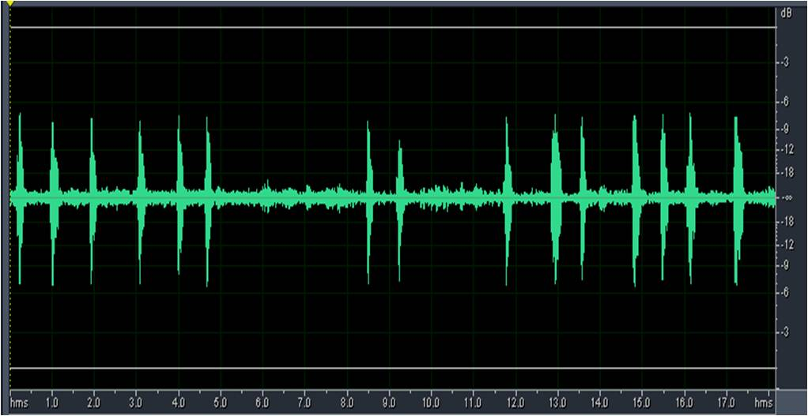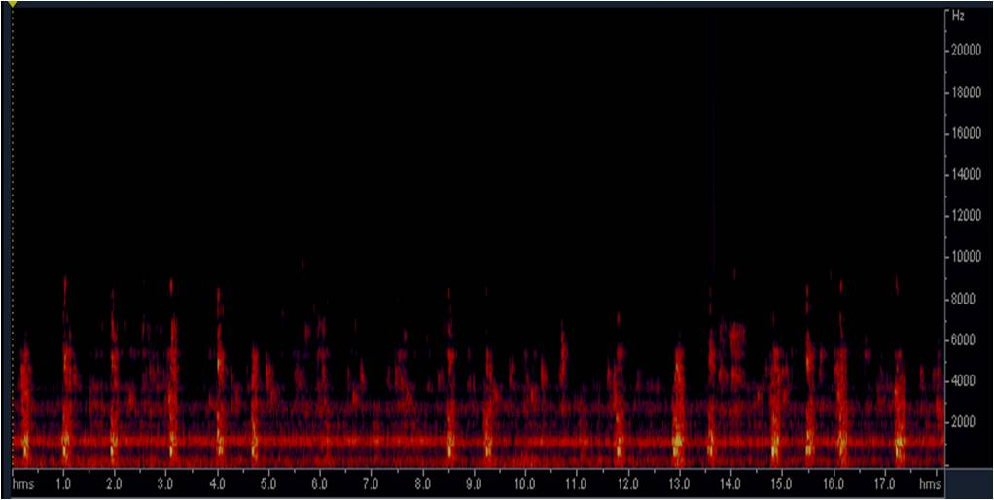
oscillogram
spectrogram
Figure 1. Vocalization of the ricefield rat during early evening (dusk call) in laboratory
During quite condition at the laboratory, the adult male rats that treated by put 3 adult female rats in the treatment cage also emit bioacoustics. The vocalization pattern looks similar sound with the dusk vocalizations. The male rats (weight 152g, head body length 158cm, tail length 151cm, and scrotal width 31cm) detected as individual who roared its vocalization. Single voice with 6 syllables on a regular recurring dominant frequency of 800Hz couple with 1.3 kHz, 1.7 kHz, 3.9 kHz and 9.8 kHz shouted in the intensity level of 12.6-45.4 dB (average 29.8 dB). During vocalization in total duration of 6.5 seconds, there were 6 repetitions with interval of 1.1 second (Figure 2). The vocalization recorded at the daylight (at 12:10 pm) when the laboratory was silent. The bioacoustics shouted by the male adult ricefield rat during walking slowly around the feeding tray while all the female rats are inside burrow.
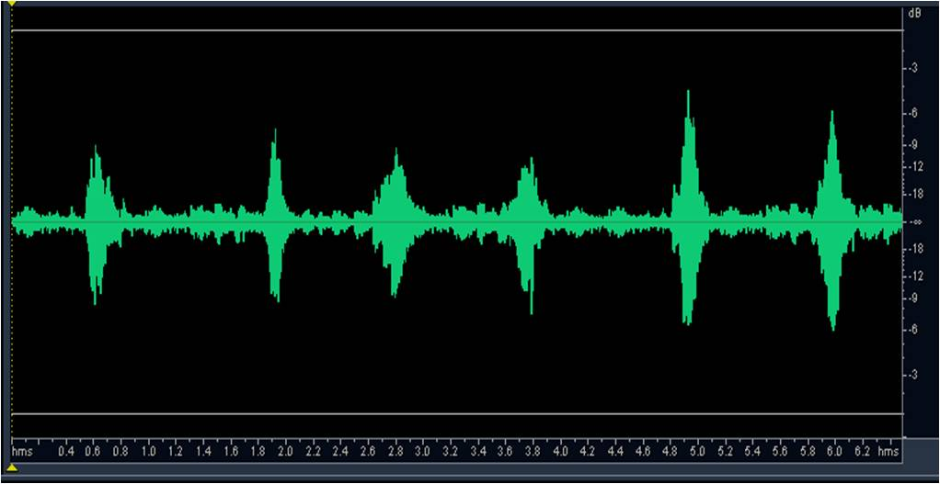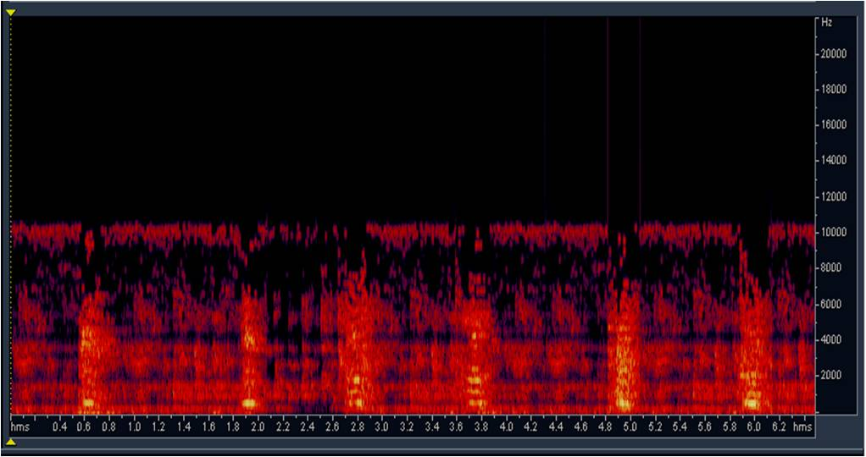Figure 2. Vocalization of the ricefield rat at the quite condition
Adult male rats with body weight 138g, head body length 135cm, tail length 130cm, and scrotal width 24cm which has 4 days inhabit in the treatment cage, call as occupant, put other adult male rat (newcomer) with similar body size (weight 136g, head body length 135cm, tail length 130cm, and scrotal width 25cm). Since the presence of a new rat, the occupant looks allocate more attention for the newcomer activities. After 5 hours newcomer put in the cage, there was a bioacoustics during evening that shouted by newcomer. The vocalization divide into 4 time period based on the rat activities, that is 0-4 second while the occupants pounding cage floor and emit vocalization in 3.6 seconds on the dominant frequency of 2.4 kHz accompanied by 1.7 kHz and 4.8 kHz with intensity level of 8.2-37.9 dB (average 28.3 dB). At the second 4th-15th, newcomer rat take a respond become ready to fight and emitted vocalizations at dominant frequency of 5.3 kHz with 600Hz, 1.2 kHz, and 3.9 kHz as background voices. Intensity level was 15.0-40.9 dB (average 27.1 dB) and roared during 12.3 seconds with 5 syllables. The newcomer voice becomes louder when the occupant moved closer. During the second of 16th-24th, there was fighting between the occupant and newcomer rat with roared vocalization by bitten rat at the dominant frequency of 3.4 kHz and 4.8 kHz coupled with 300 Hz, 2.0 kHz, 4.6 kHz, 7.9 kHz, and 10.2 kHz. Entering the 20th second, vocalization changed due to rat bitten become as subordinate (looser) and emit vocalization with dominant frequency of 5.8 kHz accompanied by 2.9 kHz, 8.9 kHz and 11.8 kHz and intensity level of 11.1-52.8 dB (average 22.9 dB) (Figure 3).
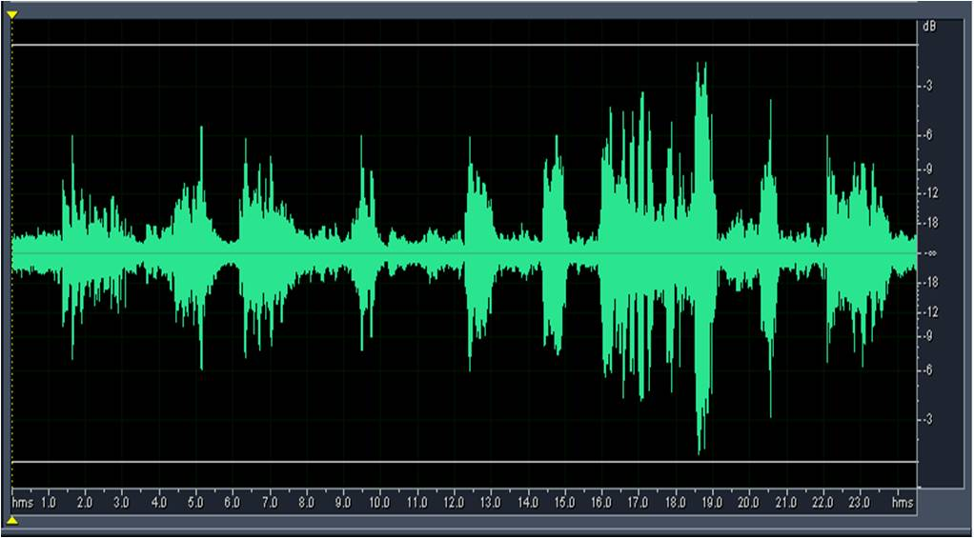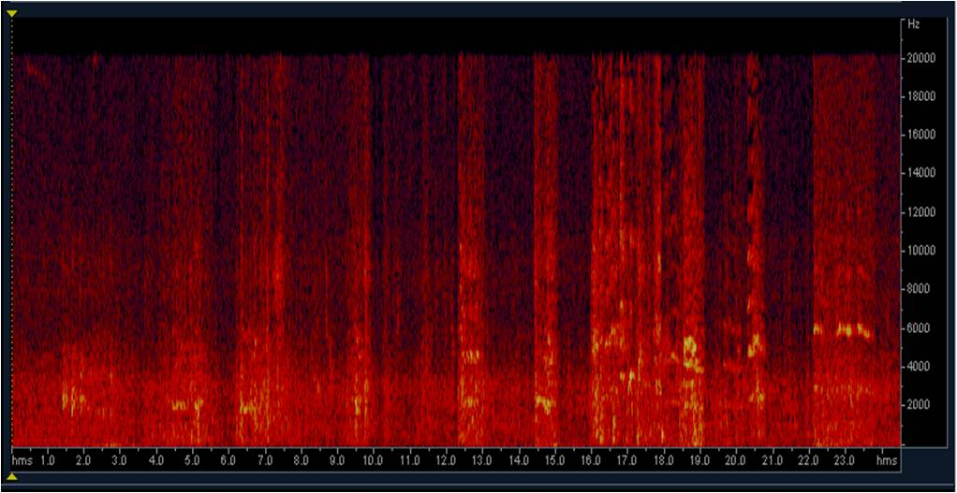Figure 3. Vocalization of the ricefield rat during early fight of two adult rats
Fighting vocalizations also obtained when two adult dominant male rats with similar body size were put in the same treatment cage simultaneous. After released, the main activities of both rats were exploring the new environment inside cage. There was a fighting between 2 males after more than 5 hours inside the same cage. The vocalization shouted by the looser rat at dominant frequency of 5.5 kHz accompanied 2.5 kHz and intensity level 9.8-66.8 dB (average 24.1 dB) with duration of 42.7 seconds (Figure 4). During fight, the rat posture changed rapidly from standing, rotating, and trying to bite each other. After one of the rats has bitten, then the looser rat ran towards the cage corner.
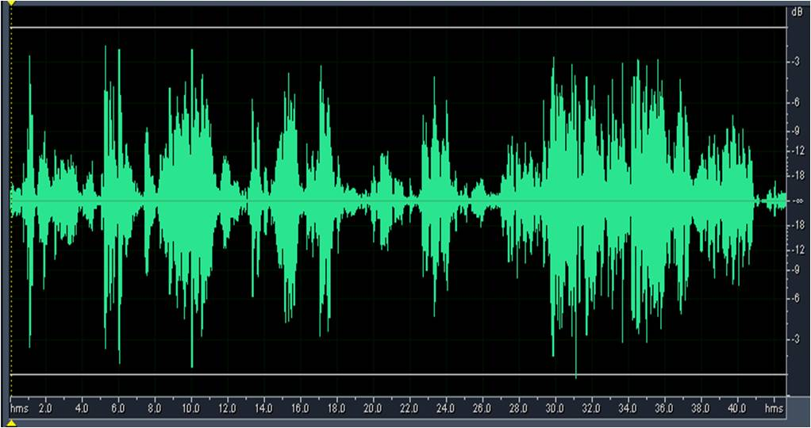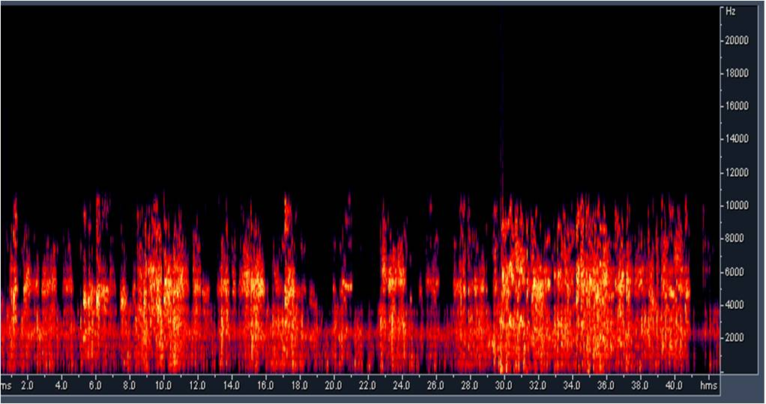Figure 4. Ricefield rat vocalization during fighting of adult male rats
Subordinate male rat which lose at a previous fight move quietly to the cage corner. The specific gesture was all their hair erect and carefully watching all activities done by the dominant (winner) rat. When the winner rat move closer, the looser rat emit vocalization at dominant frequency of 5.6 kHz coupled with 1.3 kHz and 8.4 kHz in level intensity 7.9-85.3 dB (average 21.1 dB). There were 34 syllables with interval 0.2 seconds during vocalization period in 30 seconds (Figure 5).
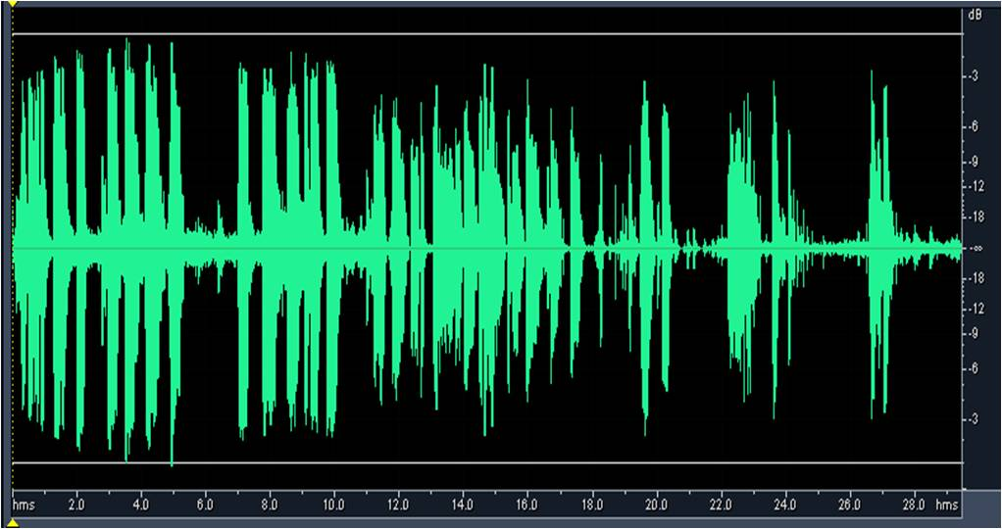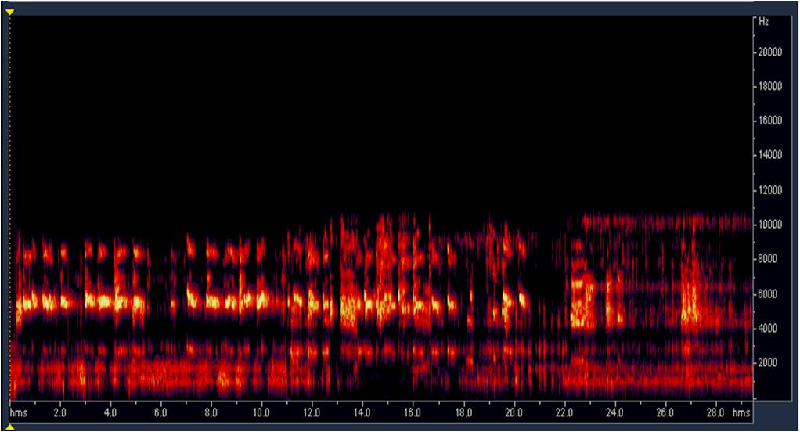
Figure 5. Male vocalization of the ricefield rat after loss at previous fight
The rat which loss in the fights usually cannibalized by the winner male although provided sufficient feed and water inside cage. The cannibalized rat usually with heavy damage head because the eyes and brain consume by the winner rat. The recorded video from CCTV showed that looser male rat did not fight back against the dominant rat when attacked. The looser rat shows out his neck while emit a scream continuous vocalizations at dominant frequency of 6 kHz accompanied by 800Hz, 2.7 kHz and 8.4 kHz with intensity level 5.9-57.0 dB (average 15.3 dB). Vocalization shouted at the duration 12.4 seconds consist of 17 syllables with interval 0.2 seconds (Figure 6).
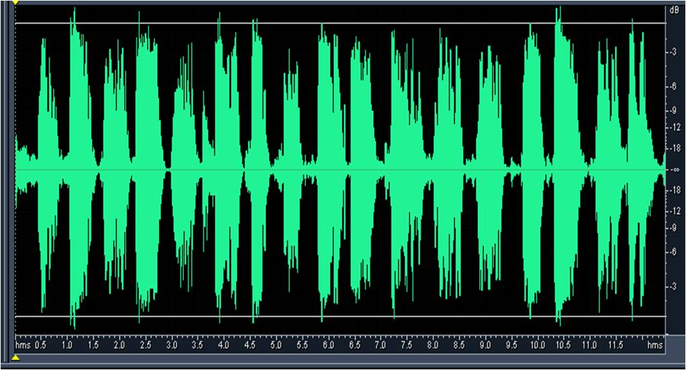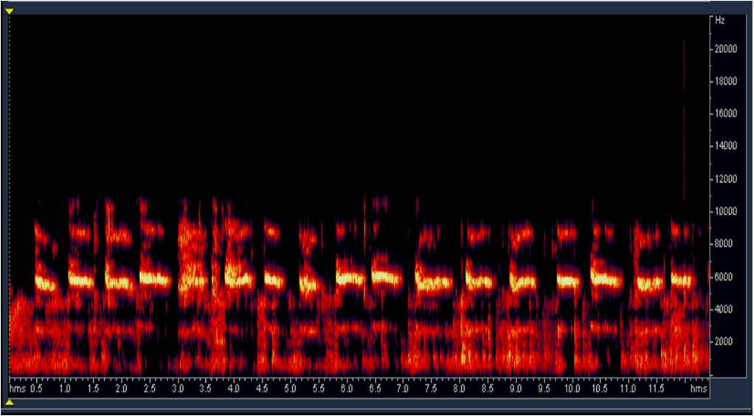
Figure 6. Vocalization of the adult male rat before cannibalized by the winner rat at previous fight
Adult male rats (weight 146g, head body length 138cm, tail length 134cm, scrotal width 26cm) put in the experimental cage that inhabited by young male rat (weight 80g, head body length 116cm, tail length 114cm long tail, scrotum width 18cm) for 2 week continuously. After released in the cage, adult male rats began explored all cage part, while the young male did not react and just quietly in the cage corner. After dusk, the young male rat look more vigilant with regard every adult male activities. Vocalization began to emit approximately 6 hours after they were placed in one cage. The dominant frequency was 5.5 kHz coupled with 2.5 kHz, 8.4 kHz and 11.3 kHz that shouted during 20.1 seconds with 6 syllables with interval 2.2 seconds and intensity level 15.1-49.7 dB (average 32.6 dB) (Figure 7).
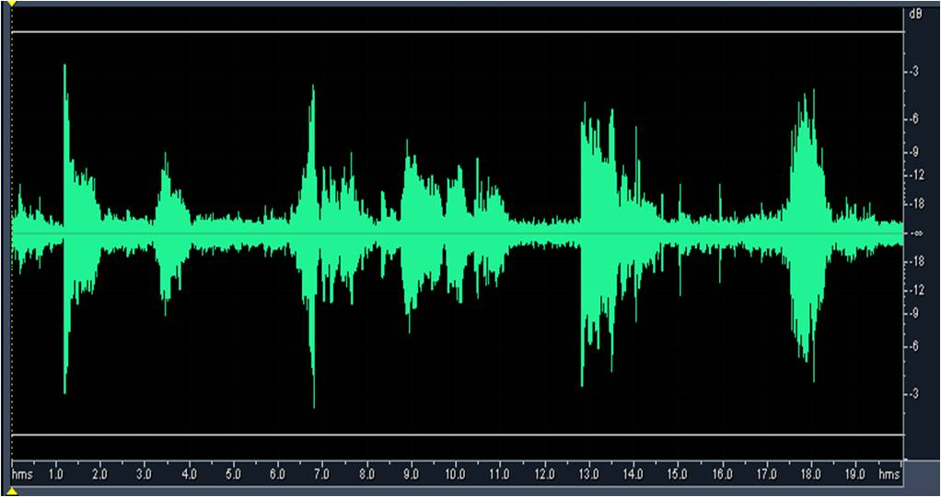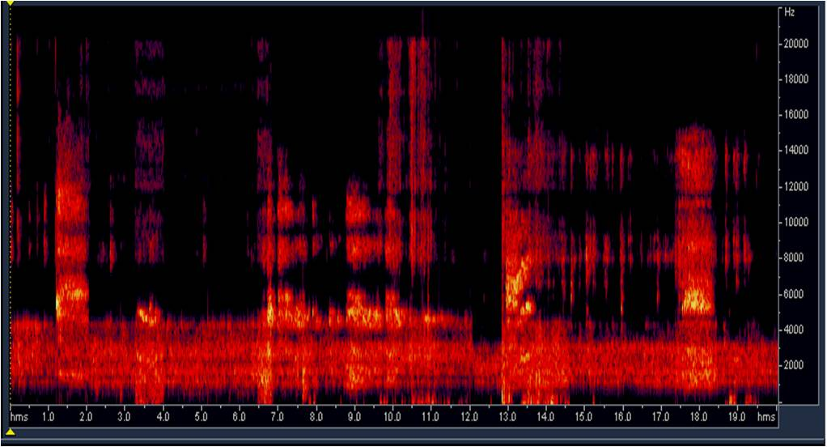
Figure 7. Depressed vocalization of young male rat by the presence of adult dominant male
Fear vocalizations by the presence of adult dominant male obtained when the young male rat (weight 90g, head body length 114cm, tail length 111cm, scrotal width 19cm) put in experimental cage inhabited by the dominant male rat (weight 156g, head body length 165cm, tail length 150cm, scrotal width 28cm) which cannibalize another male rats. Young male rat immediately ran to the cage corner and looked frightened. Depressed young male vocalizations roared at dominant frequency of 5.3 kHz accompanied by 1.3 kHz and 7.2 kHz with intensity level 16.9-34.1 dB (average 26.2 dB). During vocalization in 16.4 seconds consist of 21 syllables with interval 0.3 seconds (Figure 8). Young male rat shouted his voice louder and try to run away when adult male moved closer.
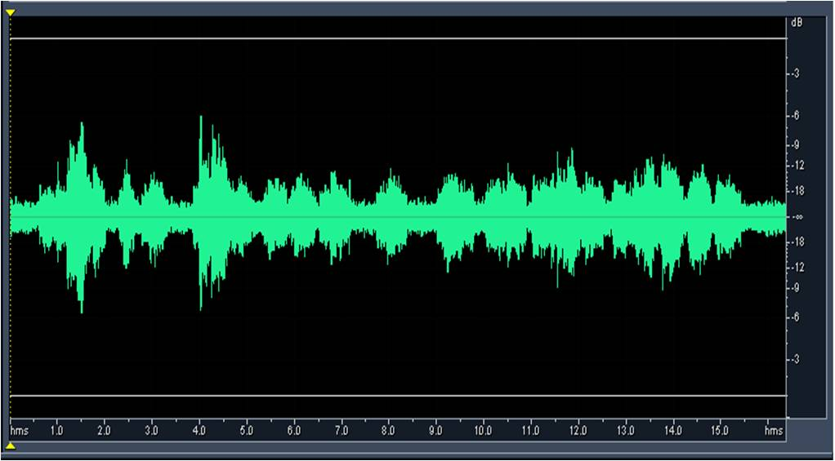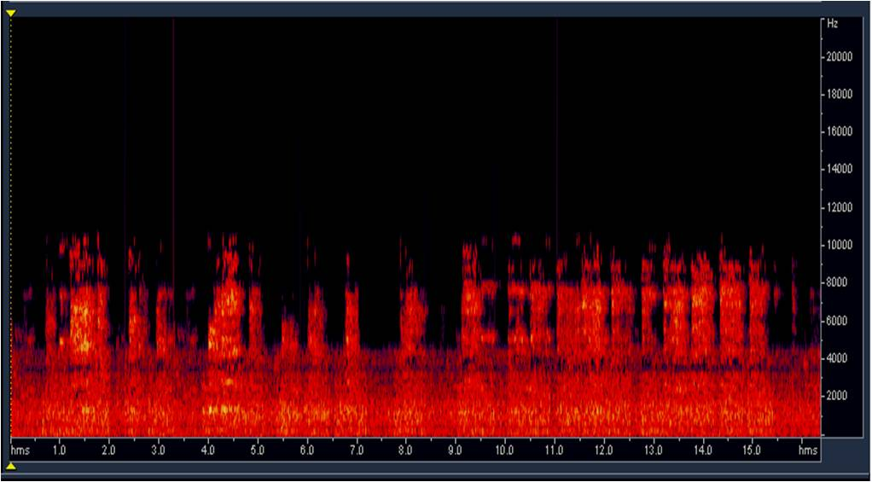
Figure 8. Fear vocalizations of young male rat by the existence of dominant male
Young male rats (weight 76g, head body length 115cm, tail length 111cm, scrotal class -1 or not active yet) emit vocalization at dominant frequency of 6.8 kHz accompanied of 1.3 kHz, 2.2 kHz, 4.8 kHz, 5.2 kHz, 7.0 kHz and 9.4 kHz before cannibalized by dominant male rat. Vocalization shouted at intensity level 11.2-46.2 dB (average 24.6 dB) in duration 73 seconds with syllables interval 0.4 seconds (Figure 9).
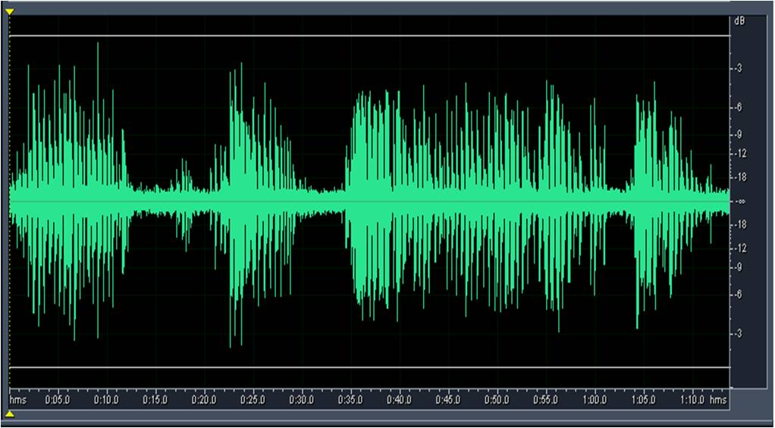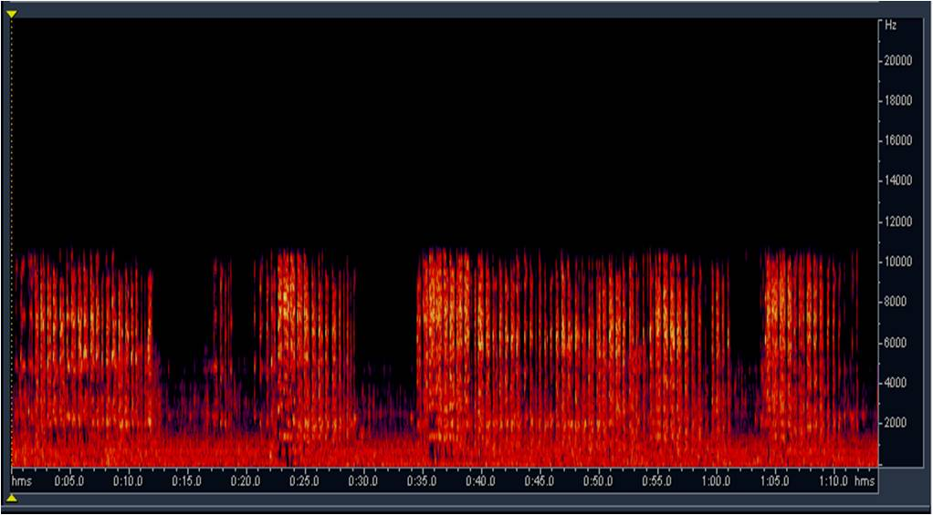
Figure 9. Vocalization of young male rat before cannibalized by dominant adult male
Adult female rat (weight 115g, head body length 130cm, tail length 124cm, vagina class 2, teat class 2) put in cage inhabited by dominant male rat (weight 126g, head body length 135cm, tail length 130cm, scrotal width 24cm). Both adult rats at active reproductive state based on the observation of their reproduction character. After entered in the cage, the female rat directly ran to the cage corner. The male rats sniffing the air and soil, and slowly moving approach to female rat. Response of the female was ran to avoid the male, whereas the male rat continuing move more gentle and slowly toward the female position, interspersed by sniffed air and cage floor repeatedly. After 4 hours, during evening (at 18:49 pm), male rat more active try to approach the female rat. Response of female rats which originally ran to escape, turned into trying to expel (boxing position posture) while emit her vocalizations in dominant frequency 5.1 kHz accompanied by 2.4 kHz, 3.4 kHz, 4.9 kHz, 11.7 kHz and 19.4 kHz with level intensity 9.9-43.3 dB (average 25.8 dB) (Figure 10). During 22.2 seconds vocalization, there were 20 syllables with interval 1.1 seconds. Male rat try more intensive to close to the female rat (second 22th-27th) with move more slowly and sniffing more frequent to the rear body of the female rats. Response of female rat was not avoid the male rat while shouted her vocalizations in dominant frequency 4.6 kHz accompanied with 2.5 kHz, 7.4 kHz and 9.9 kHz the intensity level of 16.6-40.5 dB (average 28.4 dB) for 4.8 seconds (Figure 10). Finally, after 28th second the female rat has been accept to the presence of male and roared vocalizations at the dominant frequency 3.4 kHz coupled by 9.4 kHz at intensity level 15.2-39.6 dB (average 25.2 dB) with 2-6 syllables during 11 seconds. Male rat vocalization roared after female voice at dominant frequency of 600 Hz with 2.2 kHz and intensity level 3.4 kHz with 13.5-23.6dB (average 20.1dB) (Figure 10).
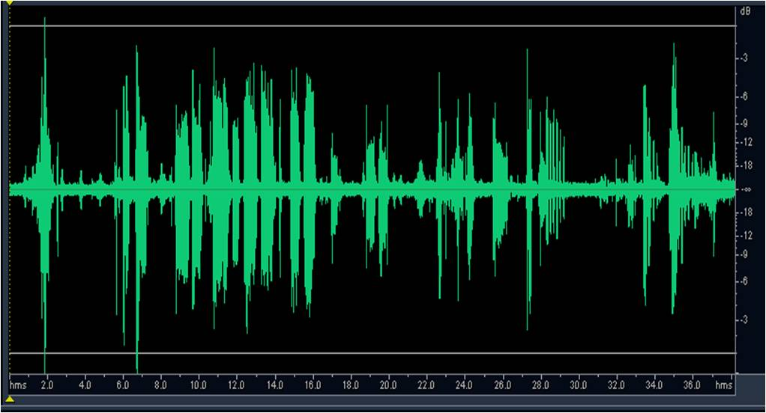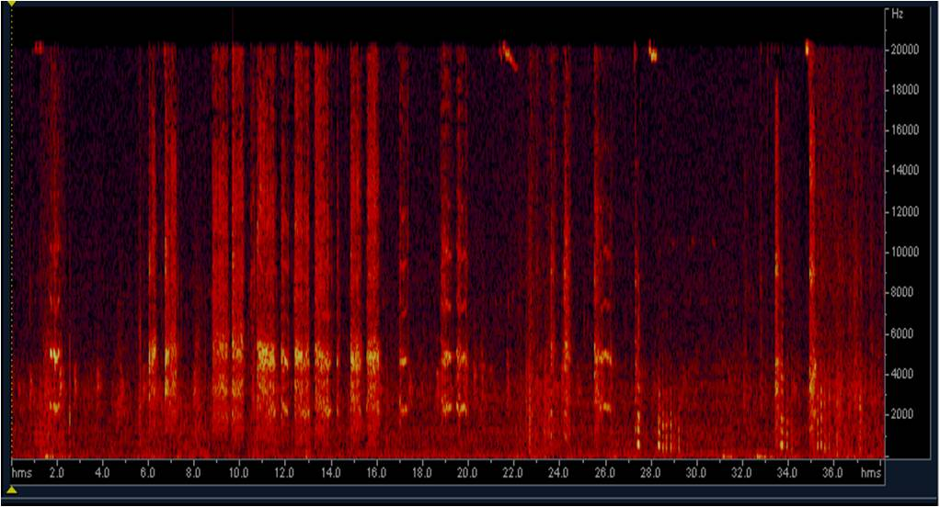
Figure 10. Vocalizations during active reproductive period of the ricefield rat
Adult male rat with biological attributes weight 163g, head body length 155cm, tail length 151cm, scrotal width 28cm, harassed by thin bamboo stick inside experiment box. The early response of ricefield rat was shocked and jump while shouted vocalization at the dominant frequency of 1,0 kHz accompanied by 5.6 kHz, 2.7 kHz, 4.3 kHz, 7.2 kHz, and 9.1 kHz during 1.4 seconds at the intensity level 21.5-32.7 dB (average 25.7 dB). When the disturbance continued, the male rat was tapping his rear legs to the cage floor and trying to bite the stick. This response done repeatedly while roared vocalizations at dominant frequency 5.8 kHz accompanied by 800 Hz, 2.4 kHz, 4.4 kHz, 8.4 kHz, and 9.4 kHz with intensity level of 12.7-34.6 dB (average 24.9dB) (Figure 11).
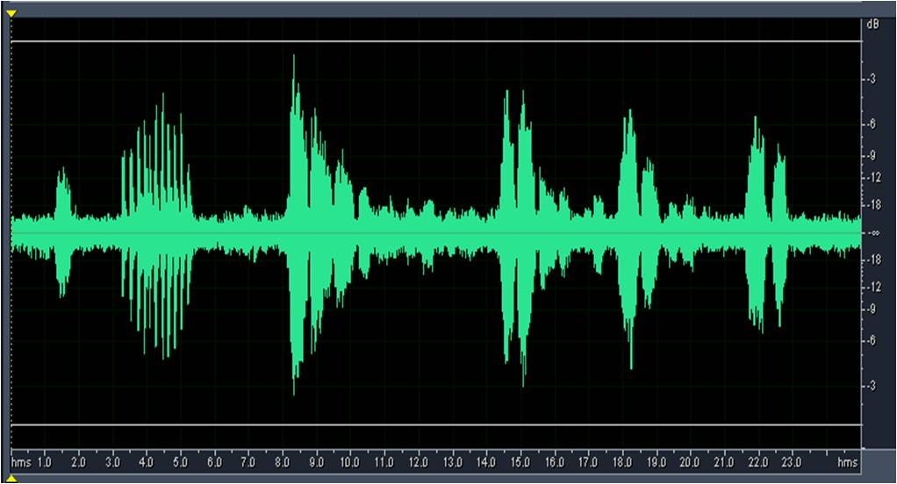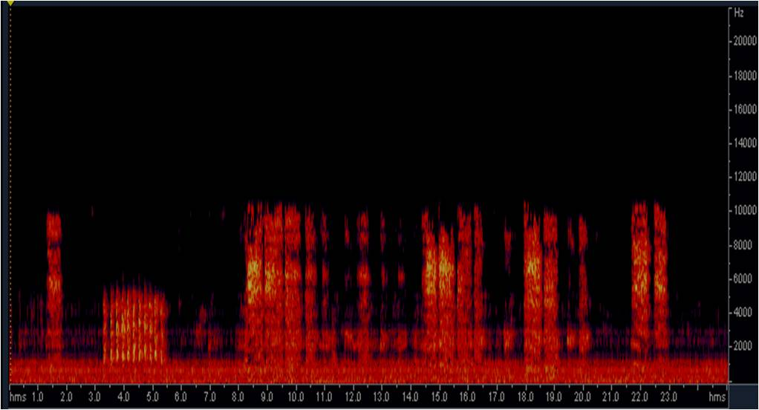
Figure 11. Vocalization of adult male rat during physically disturbed
Lactating female rat (weight 158g, head body length 146cm, tail length 143cm, vagina class 3, and teat class 3) which had 4 days pubs plagued by thin bamboo stick. First response of female rat is quiet moving away from the nest and left off her pubs. When the disturbance continued, the female rat was trying to bite the bamboo stick and emitted her vocalizations in dominant frequency of 5.3 kHz accompanied 1.3 kHz, 3.1 kHz, 6.8 kHz, and 8.6 kHz and the intensity level of 14,9-44.6 dB (average 23.3 dB) (Figure 12).
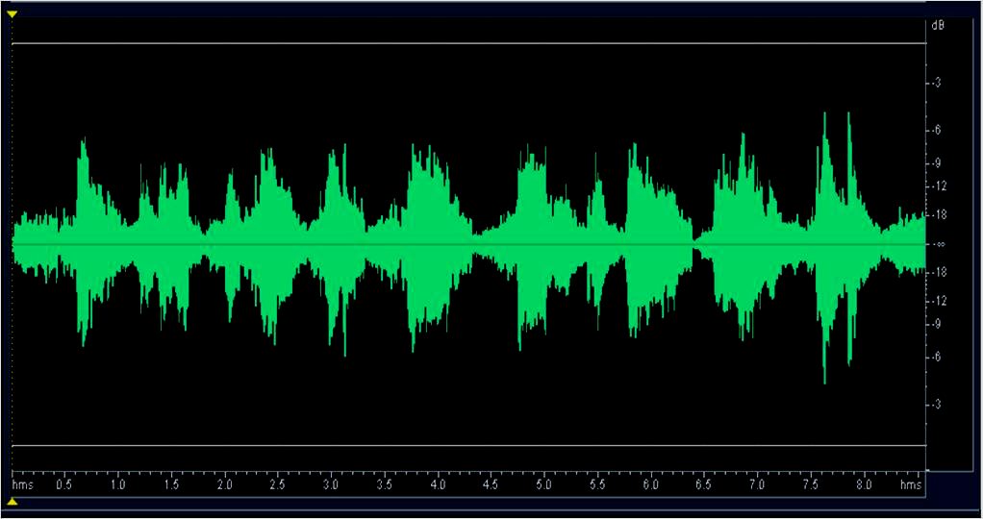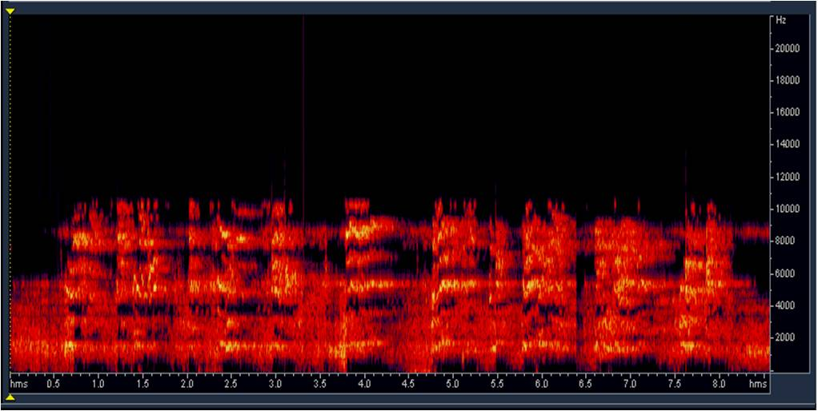
Figure 12. Vocalization of the lactating adult female rat during physically disturbed
Young male rat (weight 76g, head body length 115cm, tail length 110cm, abdominal testes or not active reproductive state) was put in the experimental cage containing 20 adult rats (5 males and 15 females). The immediately response of the young rat is fear that showed by the position of the body was curled up, all his hair erect, deep watching, and also roared the vocalization at dominant frequency of 4.8 kHz accompanied by 2.5 kHz, 7.3 kHz, 9.9 kHz, and 12.3 kHz with intensity level 11.2-46.2 dB (average 24.6 dB). During vocalization with duration of 1 minute 9 seconds, there were 43 syllables with interval 0.12 seconds (Figure 13).
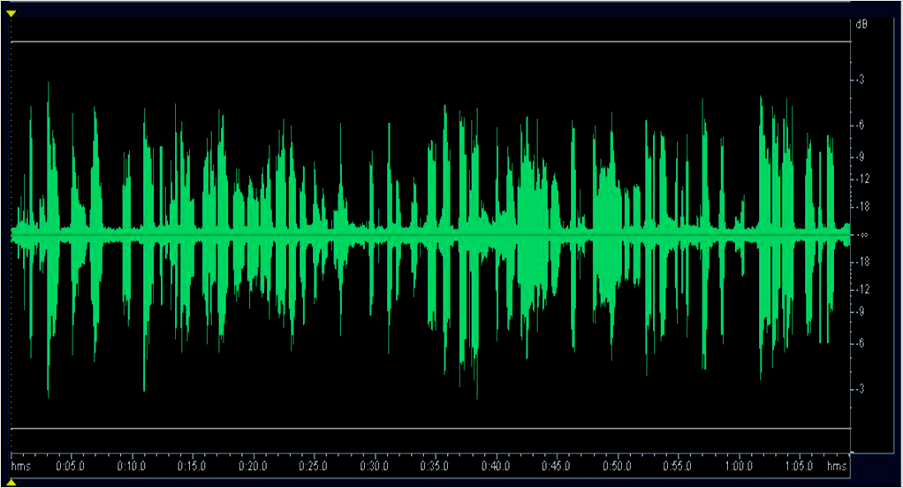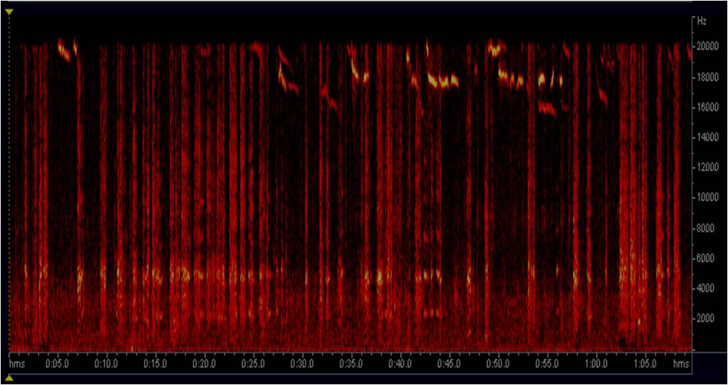
Figure 13. Vocalizations pattern of the young male rat depressed in the new population
- Discussions
Mammalian vocalization is a structure of multidimensional information code that contains the sender’s signals of motivation and reference. Visualization on spectrogram and oscillogram showed that the ricefield rat vocalization varies in frequency, duration, intensity, and repetition. The vocalization patterns also vary depending on the rat activities during shouted. Its indicate that the ricefield rat vocalization is an acoustics signals that used to deliver message to the other. Changes in the number of repetitions and variations at bioacoustics indicate that the vocalization is a coding of messages [5].
Research on the rice-field rat vocalizations conducted with the final goal to assemble a ricefield rat control method, by using the natural rat vocalization to attract them. The method control is suitable with the concept of control using TBS (trap barrier system) which has been previously assembled by ICRR (Indonesian Center for Rice Research). The research will conducted step by step with the first activity is exploring of the rice-field rat vocalization in the field and in the laboratory, purify and characterize the obtained vocalization, and then made their vocalization database. The next step is exposure the pure natural vocalizations for the rice-field rat at individual and population levels in the laboratory. The objective of the previous research was to obtain vocalizations which used as an acoustic communication signal of the rice-field rat. These vocalizations will be tested in the next experiment to find out their effectiveness toward behavioral response of closed populations of the rice-field rat at enclosure.
The exploring of natural vocalization of the ricefield rat in laboratory obtained 13 vocalization patterns. Based on rat activities and their motivation, vocalizations are grouped into five categories, i.e. fight vocalization (7 patterns), vocalizations in the population (2 patterns), disturbed rat vocalizations (2 patterns), and both 1 pattern of courtship vocalizations and dusk call. Most of the audible vocalization of the ricefield rat, 10 patterns, associated with the rat agonistic behavior such as fight and cannibalism voices. These obtained audible vocalization is bigger than similar research that conducted by [15] who explore an audible vocalization of the Chinese white-bellied rat (Niviventer confucianus). Captured wildlife population of the Chinese white-bellied rat emit four vocalization patterns in the laboratory, i.e. looser rat male voice, looser rat female voice, female voice when male present, and voice of young rat during presence of adult rats. The audible vocalization of Chinese white-bellied rat classified into two types, fear and rejected voice [5]. Fear voice with specific multi-harmonic frequencies, such as vocalization of looser individual during and after fighting, and also the young voice during presence adult dominant rat. Rejected voice has a constant multi-harmonic frequency, such as female vocalizations during present the dominant male rat. Based on these category, the audible vocalization of the ricefield rat that grouped as fear voice including vocalization of adult male rat before fight, during fighting, looser rat after fight, and cannibalism. Fear voice of young rat includes the audible vocalizations of young male during the presence of dominant male, cannibalism of young male by dominant male, and stress young male when put on 20 adult rats. Rejected voices include vocalizations of adult female rat have not been willing to accept the presence of a male for mating, and vocalizations of adult rats (male or lactating female) when disturbed. Vocalization of the ricefield rat during active reproductive and also adult male rat at dusk period or during quiet laboratory grouped as new category. Vocalization during rat fight and cannibalism were emitted at dominant frequency 5,3-6,0 kHz, vocalization of stress young rats on 4,8-6,8 kHz, vocalization female's rejected copulation on 4,6 kHz, and vocalization of the adult rat disturbed on 5,3-5,6 kHz.
The use of acoustic signals to control pests shows the progress over time. At first, the animal control target driven with a loud sound waves, call as sonic boom, such as the sound of explosion, sirens, drums, human shouted, clapping hand etc., so that the animals shock and leave certain areas. The weakness of the method is causing the disturbing noise, as well as the animals become habituate. The next development was the use of high-frequency acoustic signal (ultrasonic) to repel the target animal from the control area. Some ultrasonic claimed as natural vocalizations that emitted by target animals so effective to use. The successful application of these methods to control still varies greatly and debatable. Nevertheless, it appears that the application of ultrasonic relatively successful in a limited area.
- Conclusions
In the artificial habitat inside laboratory, exploration of the natural vocalization of the ricefield rat at an audible range voice obtained 13 vocalization patterns. Most of the rat audible vocalization (10 patterns) associated with agonistic behavior. Fighting and cannibalism vocalization emitted at dominant range frequency 5.3-6.0 kHz, fear vocalizations of young rats at frequency 4.8-6.8 kHz, vocalization of female rat during rejection mating at frequency 4.6 kHz, and disturbed rat vocalizations at frequency of 5.3-5.6 kHz.
REFERENCES
[1] Leung KPL, Sudarmaji. 1999. Techniques for the ricefield rat Rattus argentiventer. Malayan Nature J 53(4):323-333.
[2] Sudarmaji, Herawati NA. 2001. Metode sederhana pendugaan populasi tikus sebagai dasar pengendalian dini di ekosistem sawah irigasi. Penelitian Pertanian 20 (2): 27-31
[3] Singleton GR, Belmain SR, Brow PR. 2010. Rodent outbreaks: an age-old issue with a modern appraisal. In: Singleton GR, Belmain SR, Brown PR, Hardy B.(eds). Rodent Outbreaks: Ecology and Impacts. Los Banos: IRRI
[4] Carson N. 1999. How do animals communicate? [Online]. http://www.ehow.com/ way5465476animal-communication-methods.html [17 Maret 2010].
[5] Brudzynski SM. 2005. Principles of rat communication: quantitative parameters of ultrasonic calls in rats. Behavl Gen 35(1): 85-92.
[6] Jourdan D, Ardid D, Chapuy E, Eschalier A, LeBars D. 1995. Audible and ultrasonic vocalization elicited by single electrical nociceptive stimuli to the tail in the rat. Pain 63(2):237-249.
[7] Meehan AP. 1984. Rats and Mice, Their Biology and Control. Tonbrigde-Great Britain: Brown Knight & Truscott ltd.
[8] Burn CC. 2008. What is it like to be a rat? Rat sensory perception and its implications for experimental design and rat welfare. App Anim Behav Sci 112: 1-32
[9] Thomas DA, Takahashi LK, Barfield RJ. 1983. Analysis of ultrasonic vocalizations emitted by intruders during aggressive encounters among rats (Rattus norvegicus). J Comp Psy 97: 201-206.
[10] White NR, Matochik JA, Nyby JG, Barfield RJ. 1998. , The role of vocalizations in the behavioral regulation of reproductive behavior in rodents. Presented at INABIS'985th. Dec 7-16th. Internet World Congress on Biomedical Sciences at McMaster University, Canada.
[11] Portfors CV. 2007. Types and functions of ultrasonic vocalizations in laboratory rats and mice. J American Ass Lab Anim Sci 46(1):28-34
[12] Aplin KP, Brown PR, Jacob J, Krebs CJ, Singleton GR. 2003. Field Methods for Rodent Studies in Asia and the Indo-Pacific. Canberra: CSIRO.
[13] Zhou WY, Wei WH, Fan NC. 1999. A method for studying behaviour of small animals. In: Zhang ZB, Hinds L, Singleton GR, Wang ZW (1999). Rodent Biology and Management. ACIAR Technical Reports no. 45. International Conference on Rodent Biology and Management.Canbera: ACIAR.
[14] Clemins P, Johnson M. 2003. Application of speech recognition to african elephant vocalizations. Acou, Speech & Sign Pro 1:484-487.
[15] Jiang S, Ping D. 2006. Acoustic characters of Chinese white-bellied rat's voice in different individual encountering settings in captive. Zoo Res 27(1):12-17
[16] Bardeli R, Wolff D, Clausen M. 2008. Bird song recognition in complex audio scenes. In: Frommolt KH, Bardeli R, Clausen M (editor) Computational bioacoustics for assessing biodiversity. Proc. International expert meeting on IT-based detection of bioacoustical patterns, Dec.7th-10th 2007 at the International Academy for Nature Conservation.(pp: 93-102). Germany: International Nature Academy

