Electronic Waste Management in Educational Institutions of Ambo Town, Ethiopia, East Africa
Abenezer Wakuma Kitila*
PhD Candidate, MA in Urban and Regional Development Planning, Lecturer at Haramaya University College of Social Sciences and Humanities, P.O.Box 138, Dire Dawa, Ethiopia.
E-mail address: arsemawitgod@yahoo.com
Abstract
Rapid technological advancements, scale economies, and high obsolescence rate contributes a significant role in generating e-waste. The study examines electronic waste management in educational institutions of Ambo town namely; Ambo University, Ambo Micro Business and TVET Colleges. It employs survey research and comparative study. The main data gathering tools were questionnaires, interviews, observation and review of documents. Through purposive sampling technique, property management heads, directors, purchasers and storekeepers have been selected as sample respondents. The findings of the study highlighted that educational institutions are engrossed with average volume of e-waste generated from laboratories, academic and administrative staffs. Workers in General Service Department have not aware of issues related to e-waste. It is found that IT and Telecommunication, consumer and lighting equipment, control and monitoring equipment are widely generated type of e-waste. The major action taken to the discarded items is storing and to some extent donating. It was realized that absence of legislation, absence of recycling/refurbishing centers, and lack of awareness are the major challenges in e-waste management. After all the study recommends to create partnership with governmental and non-governmental organization to obtain legislation, management options, and infrastructures to ensure proper e-waste management for better human and environmental health.
Keywords: Discarded items; E-waste; Electronic Waste Management; Generation, Legislation,
------------------------------------------------------------------------
* Corresponding author.
E-mail address: arsemawitgod@yahoo.com.

1. Introduction
During the last decade, it has assumed that role of providing a forceful leverage of the socioeconomic and technological growth of a developing society. The consequence of its consumer oriented growth combined with rapid product obsolescence and technological advices are a new environmental challenge - the growing menace of ―Electronics Waste or ―E- Waste that consists of obsolete electronic devices [12].
Over the last two decades, the amount of consumer and business electronic equipment has increased continuously. At the same time, rapid changes in information and communication technologies, the concomitant increasing versatility of most electronic devices together with the downward trend in prices have led to a drastically reduced lifespan for most electronic equipment [5]. Although, today, IT industries contribute the most significant share to the E-waste stream, consumer electronics also mark a major portion of it. Moreover, most of the businesses, banking sector, academic institutes etc rely heavily on EEE and thus, add end-of-life electronic gadgets to the existing waste stream [4].
Almost every used electronic items are considered as e-waste such as discarded cellphones, cameras, CD players, TVs, radios, drillers, fax machines, photocopiers, printers, toners, ink cartridges, batteries, re-chargeable batteries, digital calculators and clocks, CRT monitors, electric solders, computer mother boards, key board, industrial and house hold electronic machinery such as oven, fridge, sewing& washing machines, fan, air-conditioner, grinder, iron, heater, military and laboratory electronic equipment’s, etc [1].
The rapid growth of technology, rise in per capita income of people in developing nation, up gradation of technical innovations and a high rate of obsolescence in the electronics industry have led to one of the fastest growing waste streams in the world which consist of end of life electronic waste products [6]. Electronic waste or e-waste is one of the fastest growing waste streams around the world, growing at a rate of 3–5% per annum or approximately three times faster than normal municipal solid waste [19].
Managing electronic waste (or e-waste) is one of the most rapidly growing pollution problems worldwide. New technologies are rapidly superseding millions of analogue appliances leading to their disposal in prescribed landfills despite potentially their adverse impacts on the environment. The consistent advent of new designs, ‘‘smart’’ functions and technology during the last 20 years is causing the rapid obsolescence of many electronic items. The lifespan of many electronic goods has been substantially shortened due to advancements in electronics, attractive consumer designs and marketing and compatibility issues [7].
2. Statement of the problem
Worldwide electronic & electrical equipment waste is the fastest growing stream with challenges like e-waste management and trained manpower to handle and sort the e-waste and implementation of proper technology to avoid health related issues [11]. E-waste is going to become a great challenge for environmentalists and technologists as the rate of growth is much higher than the rate it is disposed off, reused or recycled [3].
Rapid technological changes shorten the lifespan of electronic equipment. Thus, older, broken and unserviceable e-waste is generated. In the environments where there is poor maintenance, repairing, recycling activities and limited success of reuse and refurbishment, there will be increasing the generation and accumulation of tones of e-waste in households and organizations.
Analysis of the international market for electrical and electronic equipment (EEE) shows that products like televisions, refrigerators, washing machines and sound systems have reached relatively stable output levels in developed countries, while in emerging countries the markets for these devices are still expanding, due to increasing income levels and urbanization. In developing countries, these markets can be said to be mature. This same is not true for other products, such as computers and mobile phones. At the international level, the markets for these products are still expanding rapidly [10].
However, many developing countries lack the technology, facilities, and resources needed to properly recycle and dispose of e-waste. It is confirmed that limited safeguards, legislation, policies and enforcement of the safe disposal of imported e-waste and electronic goods have led to serious human and environmental problems in developing countries [7].
Recyclers in developing countries that receive e-waste from other countries frequently rely on rudimentary techniques to extract valuable materials from e-waste. E-waste is physically dismantled by using tools such as hammers, chisels, and screw drivers. Some e-waste workers are not fully, if at all, aware of the potential health risks involved with e-waste recycling. Among some communities, e-waste recycling is considered more desirable than scavenging through non electronic waste. Much of the informal e-waste recycling done in scrap yards and homes is done by children [8].
Studies indicate that unprotected exposure to e-waste is not advisable for any individual. Of exposed groups, children are particularly vulnerable to many of the components in e-waste [8]. In the study area it is realized that the educational institutions have engrossed with average number of e-waste. It is found that various types of old, broken, obsolete and unserviceable e-waste are accumulated. It has been observed, on the other hand, that there are no recyclers and refurbishes that dismantle or recycle parts of electronic items which are discarded as e-waste. Communities in the educational institutions have also holds large volume of e-waste with them.
There is an urgent need for improvement in e-waste management covering technological improvement, operation plan, implementing a protective protocol for the workers working in e-waste disposal and educating public about this emerging issue posing a threat to the environment as well as public health [3].

3. Review Literature
In simplified terms e-waste is electronic goods which have been used till end of their life span and have been discarded by their users. This may include items such as hard ware computers, CDs, printers, scanners, copiers, calculators, fax machines, battery cells, cellular phones, transceivers, TVs, refrigerators air-conditioners etc. There is no standard definition available for e-waste, each country has come out with differ definitions [13].
E-waste has been put on the priority waste streams list, and is among the fastest growing waste streams. Rapid changes in technology, changes in media (tapes, software, MP3), falling prices, and planned obsolescence have resulted in a fast-growing surplus of electronic waste around the globe. Electronic waste is becoming a "rapidly expanding" issue [15].
Concern about the effects on health of chemical exposure to e-waste and e-waste recycling is increasing despite the paucity of solid research. Reported adverse effects include: fetal loss, prematurity, low birth weight, and congenital malformations; abnormal thyroid function and thyroid development; neurobehavioral disturbances; and genotoxicity., However, few direct studies have been undertaken. Children and developing fetuses are particularly susceptible and evidence of adverse effects in early life via ecological exposure is increasing [14].
The short- and long-term effects of exposure to hazardous e-waste substances are not fully understood, however, there is research on the association between e-waste exposure and higher levels of chemicals and metals in human-derived biological samples [8]. WEEE disposal is still a worldwide challenge, since in many countries there is no structured system of reverse logistics and most WEEE is still disposed in landfills or in the open places exposed to the weather. This form of disposal can contaminate the soil or subsoil with metals and/or toxic substances from WEEE [17].
The management of e-waste should be thought at different stages. It will begin at the point of generation to the end of the product. At the time of manufacturing it begins at the industry. This can be done by waste minimization techniques and by sustainable product design. Waste minimization in industries involves adopting: inventory management, production-process modification, volume reduction, recovery and reuse greener packaging [16].
Managing e-waste encompasses not just the disposal or recycling, but also the pre-disposal logistics involved in collecting and transporting the waste. It also includes strategies for reducing the total waste generated, in line with the 3R principle - ‘Reduce, Reuse and Recycle’. Organized management of e-waste is necessary because of several reasons.
Studies have shown that most developed countries are successfully managing their e-waste through the formulation of effective legislations, development of recycling infrastructures and by strictly adhering to the principle of extended producer responsibility (EPR) which compels manufacturers to take-back used electronic products. In developing countries, the management of e-wastes is causing concern because of the lack of adherence to the norms of proper documentation of electronic devices imported or smuggled into the country, the low awareness in the society about the environmental and health impacts of hazardous substances contained in e-wastes, and failure to regulate illegal e-wastes recycling operators [20].
[18] Also share these observations and outline a number of management issues in managing e-waste in developing countries. The majority secondhand electronics exported to developing countries are unusable junks, crude recycling and backyard-recycling activities are prevalent, discarded e-waste is disposed the same way as traditional wastes, and there is no separate handling and treatment for e-waste. As far as Africa is concerned, it is known that many African countries receive second-hand equipment. Most electronic equipment exports to Africa are not pretested for functionality [17].
The authors also point out the absence of infrastructure for appropriate waste management, an absence of legislation dealing specifically with e-waste, an absence of any framework for end-of-life (EoL) product take-back or implementation of EPR as the main challenges for managing e-wastes [18].

In addition to this, studies revealed that public education and outreach maybe the most important component. That is because no matter what infrastructure is available and developed, what the laws are, and what the option are, no one will be aware of it without public education [3].

4. Methods and Materials
It is survey and comparative type of research. Based on this and the research questions, appropriate sampled areas and respondents was selected. Through non-probability sampling, the process of sampling considers different stages of sampling. In fact from various organizations, business and education institutions, and service sectors found in the town, only education institutions were the emphasis of this study. This is done based on the premise that they are engrossed with high volume of e-waste than others.
Table 1: Sample Respondents and Sampling Educational Institutions
S.N | SAMPLED AREAS | NUMBER OF SAMPLED RESPONDENTS | ROLE OF SAMPLED RESPONDENTS
I. | Educational Institutions | 20 | GSD workers
1 | Ambo University | 8 | GSD workers
2 | Ambo Micro Business College | 4 | GSD workers
3 | Ambo TVET College | 8 | GSD workers
NB: GSD (General Service Department)
Similarly using a non-probability sampling type, respondents for this research was selected based on their intimate links with the issue under investigation. Firstly, the institutions (which the key informants are representing) in this study are divided into three sub categories: the directors, purchasers and storekeepers (General Service Department officers).
The main data collection tools were questionnaires, interviews, observation and document reviews. First all the collected data were organized in to a meaningful context in order to generate well-articulated findings. Both qualitative and quantitative data analysis have been employed to analyze all the information collected via all sources. Finally, the results were presented in simple descriptive statistics such as frequencies and percentages, table, graphs and figures.
5. Results and Discussion
Education level and managerial experiences of workers could highly be associated with awareness and proper management of e-waste in educational institutions. Concerned with the respondents characteristics and background information, 55% and 45% of the sample respondents are male and females respectively. Half of the respondents’ holds BSc/BA degree while 40% are diploma. With regards to the service years, about 40% and 35% of the respondents served from 6-10 and 1-5 years in the General Service Department of the selected institution.
Table 2: Backgrounds of the Sample Respondents
Institution | Elements
Institution | Sex |  | Education Level |  |  | Service Years
Institution | M | F | Diploma | BSc/BA | MSc/MA | 1-5 | 6-10 | >10
Ambo University | 3 37.5% | 5  62.5% | 2  25% | 4  50% | 2  25% | 2  25% | 3  37.5% | 3  37.5%
Ambo TVET College | 6  75% | 2  25% | 5  62.5% | 3  37.5% | - | 4  40% | 3  37.5% | 1  12.5%
Ambo Micro Business College | 2  50% | 2  50% | 1  25% | 3  75% | - | 1  25% | 2  50% | 1  25%
Total | 11  55% | 9  45% | 8  40% | 10  50% | 2  10% | 7  35% | 8  40% | 5  25%
Source: Field Survey, 2015
When it comes to discuss particular to each institutions, the general service department workers of Ambo university has served for more than six and ten years whereas Ambo TVET college workers served for 1-5years, and half of the workers in Ambo Micro business college served from six to ten years in the general service department. Concerning to educational status of workers in each institution, majority of 50% and 75% sample respondents of Ambo University and Ambo Micro Business College holds BSc/BA degree. Whereas, majority of the sampled respondents of Ambo TVET college holds diploma. In general, therefore, it can be concluded from this discussion that almost all of the workers in the general service department have experiences and knowledge of issues related to property management. In fact, it doesn’t mean that they have awareness and knowhow of managing e-waste, hence, e-waste management will be influenced by cumulative factors. But it is crucial mainly in generating data for the study topic.
Associated with the three R’s in e-waste management, Reduce, Reuse and Recycle, purchase of electronic equipment need attention. Particularly to reduce is to work with reducing of e-waste generation through purchase of reputable and products with high durability. On the other hand, it is to mean less reliance on purchasing of secondhand market. In this regard the study highlighted that Ambo University is done purchase of electronic equipment needed through national bid which is guided by the federal service and procurement department, hence, it is public/state University. Whereas both Ambo Micro Business College and Ambo TVET College has purchased from general distributor and sometimes owned from donors. Particularly, Ambo TVET College has received about 30 computers as a donation that ends up with 20 of them were non-functional. Beside this, the results obtained through interview showed that the bureaucratic system associated with purchasing and procurement has influenced the institution in order not to purchase equipment with high reliability and durability which could be resulted in receiving of broken and non-functional electronic items.
Concerning to reasons to purchase new electronic equipment, it is reported that, it is not only rapid technological advancement and economies of scale that influences purchasing of electronic equipment, but related to increasing number of students and opening up new academic programs, purchasing of new electronic equipment have been taking place even if the older once are functioning.
Figure 1: The Most Widely Available Electronic Waste in Educational Institutions
Source: Field Survey, 2015
The study also highlighted that e-waste in Ambo University generated from staff members is (35%), laboratories (46%) and administrative workers (19%) whereas in Ambo Micro Business college about (78%) of e-waste have been generated from ICT laboratories and in Ambo TVET college 85% of e-waste is generated from laboratories and staff members. It can be concluded that huge volume of e-waste has been generated from laboratories in those institutions.
As it can be understood from figure 1, desktop computers are the most widely generated electronic waste in all institutions followed by straight fluorescents and UPSs. This is due to the fact that students, academic and administrative staff members rely on PCs to perform educational tasks. On the other hand the lifespan of computers is very short that it will contribute a significant level of e-waste generation in those institutions.
Concerning to awareness associated with electronic waste, the survey result depicted that majority of the sample respondents (95%) of Ambo University, (82%) of Ambo Micro Business College, and (75%) of Ambo TVET college are conscious/aware of the volume of electronic waste that they generate. Because they have been striving to control and record the quantity and characteristics of e-waste generated from laboratories, academic and administrative staffs. Particularly, Ambo University has adopted and implemented the caisson program to administer and manage property of the university.
Paradoxically, 92%, 78% and 64% of the sample respondents of Ambo University and 94.5%, 83% and 91.5% of the sample respondents of Ambo Micro Business college as well as 84%, 65.5% and 71.5% of the sample respondents have not aware of any ¹health or environmental risks associated to improper disposal and management of e-waste, have not known of ²any local or international laws pertaining to electronic waste management and have not aware any ³local programs, projects pertaining to electronic waste management. Similarly for the question item that request respondents whether they have aware of any company/ body that collects discarded electronic waste, 100% of the respondents of both Ambo Micro Business college and Ambo TVET college have not aware of it while 75% of Ambo University general service department workers have not aware of it. It can be understood that there is no company that collects discarded e-waste from these institutions thus it would directly influencing e-waste management.
The study highlighted, as indicated in figure 2, that among the four major categories of e-waste IT and Telecommunications such as computers, laptops, printers, LCD monitors, copy machines and etc are widely available in all institutions followed by lighting equipment such as luminaries, compact and straight florescent. Consumer equipment namely TVs, UPSs, DVD players, projectors, radios and etc are also present in the three institutions. Finally monitoring and control is the least available e-waste category.
Figure 2: Quantity and Types of E-waste Generated in Educational Institutions
Source: Field Survey, 2015
Compared to the two other institutions, Ambo TVET College has generated less volume of e-waste. This is due to the fact that since it is technical and vocational education, simple maintenances were undertaken and the spare parts of the discarded items are used by the students during practical sessions. With regards to the question of why do you replace old electronic equipment to new, about 78.5%, 67% and 86.5% respondents of Ambo University, Ambo Micro Business college and Ambo TVET college replied that they replace because the older once are too slow and obsolete which are incompatible with the existing accessories. Regarding to the actions taken to the discarded items generated from laboratories, academic and administrative staffs, it is reported that about 100% of the respondents of Ambo Micro Business College and Ambo TVET College as well as 68% of the respondents of Ambo University reported that the major action taken to e-waste is storing.

Figure 3: Major Actions Taken to E-waste
Source: Field Survey, 2015
While 45% of the respondents of Ambo University reported that some of the electronic equipment which once were waste have been donated to the nearby schools after maintenance (figure 3).
Figure shows the major actions taken to the discarded electronic waste in each institution. Accordingly the three educational institutions have put huge volume of generated e-waste in storage. However, as it is observed Ambo University has donated about 252 of various electronic wastes to the nearby schools after maintaining the broken and non-functional equipment. On the other hand none of the institutions didn’t sell electronic wastes to e-waste businesses or other companies, hence, there are no recyclers or refurbishes in the country. Therefore, it can be understood from this statement that due to weak or absence of legislation specifically deals with e-waste, educational institutions in the town have considered storing of e-waste as the first option in e-waste management.
E-waste management is a complex task due to its hazardous and toxic nature and less awareness towards it. The major challenges in e-waste management, as mentioned by the sample respondents, are highly related to rules and regulation. There is no legislation that specifically deals with e-waste that the institution is aware of it. Above all, they were informed by the higher government body not to take any action towards e-waste except donation. However, respondents of Ambo University has reported that the Federal Procurement and Service Agency, which is a government body that enforces laws and regulation towards government property, has on the verge to collect all the e-waste stored in the institution. The other challenge is absence of professionals and refurbishes who can dismantle and maintain all the broken and non-functional e-waste in the storage.
Studies indicate that the storage areas for storing the electronic waste could be the warehouses hired for the purpose of storage. Within the warehouse, appropriate containers should be used for storing different electronic waste items separately and there should be no mixing of different kinds of e-waste. No other types of waste should be mixed with e-waste.
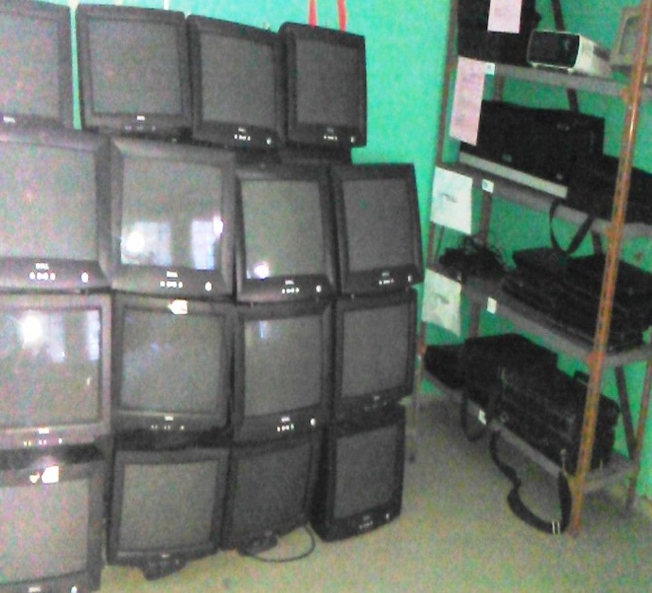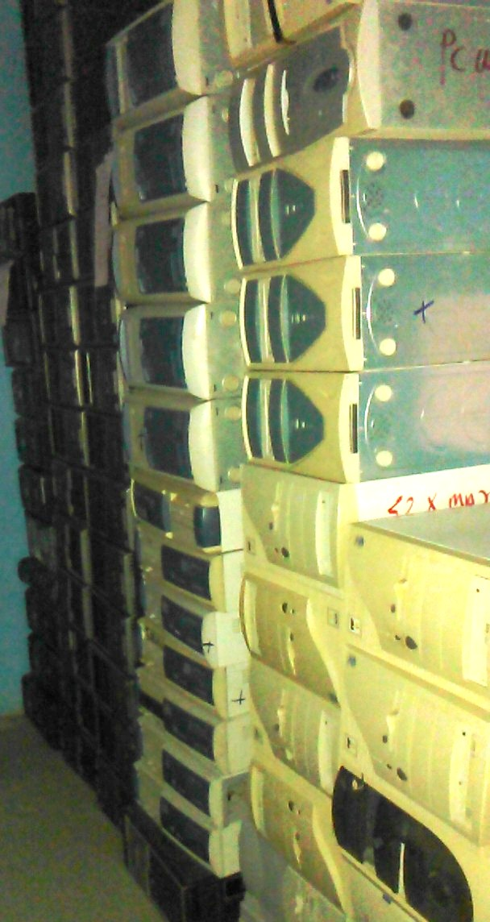
Figure 4: E-waste in Storerooms of Ambo University.
Source: Field Survey, 2015
In this regard, the research has observed the storerooms of the selected educational institutions. As it is seen in figure 4, for instance, in the storerooms of Ambo University and Ambo Micro Business College, e-waste items are stored separately some of them are on the ground and some others are on shelves. However, the General Service Department head reported that it was accumulated in disorganized manner mixed with other types of waste materials before caisson program is implemented in the university though the storerooms are not appropriate and sufficient to handle e-waste.

6. Conclusion
The study highlighted that the selected educational institutions are purchased electronic equipment needed for the teaching learning purposes through national bid, from general distributors and sometimes owned from donors as a donation. Most of the General Service Department workers have aware of the volume of e-waste generated from laboratories, academic and administrative staffs. In paradox, most of the workers have not aware of the health and environmental risks associated with e-waste, any legislation that deals with e-waste and companies or recyclers that collect e-waste. The major action taken towards the discarded items is storing. It does to mean that other e-waste management options such as refurbishing and recycling have not yet undertaken. The institutions are engrossed with high volume of IT and Telecommunication, lighting and consumer equipment. Among the major e-waste categories desktop computers, UPSs, laptops, LCD monitors, fluorescents and stabilizers are the most widely generated and available e-waste in the storage. It was discussed that the main challenges of e-waste management in the educational institutions are absence of legislation that deals with e-waste, shortage or absence of recyclers and refurbishing shops as well as lack of awareness. The bureaucratic system associated with purchasing and procurement has influenced the institution in order not to purchase equipment with high reliability and durability which is resulted in increasing generation of e-waste.
7. Recommendation
Based on the findings of the study both short term and long term recommendations were made. In the short term program it is better to establish a committee who is responsible to undertake e-waste accounting and inventory. In this regard all the e-waste items need re-classification according to their label as obsolete, non-functional and non-repairable items. Appropriate storage with sufficient containers and shelves should be prepared to properly store the discarded items. In the long run it is better for the educational institutions to create partnership with governmental and non-governmental organizations which are working on environmental protection, waste material recycling and related activities. It is also highly recommendable for the national government to formulate legislation, rules and regulation that specifically deals with e-waste management in educational institutions.
Limitation of the Study
Though, the study will pave ways for other scholars to undertake intensive research on the issue, it was not free of limitations. Firstly, the researcher has encountered tackles in generating accurate data with regards to quantity of electronic waste in the selected institutions. Thus it took ample time to investigate documents and to count the items. Secondly, associated with limited finance, the study was not comprehensive in that it doesn’t consider all the campuses of Ambo University and other colleges in the town.
Acknowledgment
I take this opportunity to express my gratitude to Dr. Yergalem Mahiteme, who has been an assistant professor at Addis Ababa University, Ethiopia, for his encouragement to undertake a research with this study topic. I would also like to thank all the workers of General Service Departments whose role have been uncountable in generating data pertaining to the study. My thanks goes to Mr. Sileshi Talegeta, Mr. Ayana Gemechu and Mr. Ermiyas Nemomsa, who are lecturers at Ambo University for continuous moral support in the journey of the study. Last but not the least, I would like to thank my father Wakuma Kitila, my mother Mestawot Addis and my brother Robson Wakuma as well as both of my sisters Tsion Wakuma and Tizita Wakuma for supporting me spiritually throughout writing this paper.
References
- S. Sivakumaran, (2013) E-Waste Management, Disposal and Its Impacts on the Environment. Universal Journal of Environmental Research and Technology, 2013 Volume 3, Issue 5: 531-537
- S.B. Wath et al., (2010) A roadmap for Development of sustainable e-waste management system in India. Science of the Total Environment 409(1) 19-32.
- K. J. Manoj et al., (2014) E-waste, A new challenge to the Environmentalists. An International Quarterly Journal Volume 13, No 2 pp 333-338
- Borthakur and Sinha (2013) Electronic Waste Management in India: A stakeholder’s Perspectives. Electronic Green Journal 1(36).
- P. Tanskanen. Management and recycling of electronic waste. Acta Materialia 61 (2013) 1001–
- K.R Takale (2015) Electronic Waste & Its Present Scenario for Pune City International Journal of Innovative Research in Science, Engineering and Technology Vol. 4, Issue 6, June 2015.
- P. Kiddee et al., (2014) Journal of Waste Management 33 (2013) 1237–1250.
- N. Devin (2014) E-waste: A Global Hazard 2014;80:286-295
- F.Y. Fraige et al. Journal of Environmental Planning and Management Vol. 55, No. 2, March 2012, 161–175.
- M.G. Araújo et al. A model for estimation of potential generation of waste electrical and electronic equipment in Brazil/ Waste Management 32 (2012) 335–342
- Z.B.Pathan and A. D. Shaligram (2013) Study on Electronic Waste Management in Pune.
- B. J. Mohite (2013) Educating about Formal Recycling Processes: Solution for Managing EWaste in India
- T. K. Sumskrutha, (2013) Integrated e-waste Management – A Case of Gujarat. National conference on hazardous e-waste management.
- G. Rajendra et al, (2013) E-Waste: A challenge to health and environment. National conference on hazardous e-waste management.
- A. K. Walunj (2013) Hazardous Electronic Waste (E-Waste) Management Issues and Impacts on Environment and Human Health in India.
- P.B. Buchade (2013) E waste Management: Packaging perspective. Abasaheb Garware College, Karve Road, Pune – 411004.
- H.M. Veit and A.M. Bernardes, (2015) Electronic Waste: Generation and Management. Springer International Publishing Switzerland (2015) H.M. Veit and A. Moura Bernardes (eds.), Electronic Waste, Topics in Mining, Metallurgy and Materials Engineering, DOI 10.1007/978-3-319-15714-6_2
- O. Osibanjo and I. C. Nnorom, “The Challenge of Electronic Waste (E-Waste) Management in Developing Countries,” Waste Management Research, Vol. 25, No. 6, 2007, pp. 489-501. http://dx.doi.org/10.1177/0734242X07082028
- S, Schwarzer et al, (2005) E-waste, the hidden side of IT equipment’s manufacturing and use. UNEP Early Warning on Emerging Environmental Threats No. 5. Switzerland: Untied Nations Environment Program.
- Afroz et al (2013) Electrical and Electronic waste management. A case study in university of Duhok, Iraq, International Journal of Economics and Management Engineering, Volume 3 Iss.2, pp. 68-73.

