The Model to Prove the Authenticity of Cocoa Beans Based on Intelligent System

Yusriana^{a*}, Yandra Arkeman^{b}, Sapta Raharja^{c}, Purwiyatno Hariyadi^{d}

ªDepartment of agricultural post harvest and technology, Faculty of Agriculture, University of Syiah Kuala, Banda Aceh, Indonesia

^{b,c}Departement of agroindustrial technology, Faculty of agricultural technology, Bogor Agricultural University, Indonesia

^{d}Departement of Food Science and technology, Faculty of agricultural technology, Bogor Agricultural University, Indonesia

ªEmail: yusriana_ismail@yahoo.co.id

Abstract

The characteristics of chocolate depend on the cocoa origin and processes, i.e. from cultivation, harvest, fermentation, up to drying processes, not to exclude the cocoa from Aceh, Indonesia. To protect the characteristics, a model to prove the authenticity of origin of the cocoa beans is required. The purpose of this study is to produce a model to prove geographical authenticity of cocoa from Aceh, in this case the model developed is based on intelligent systems. The input used was the physical and chemical characteristics. As a comparison, cocoa beans from other regions in Indonesia, namely Lampung, South Sulawesi and East Java, were used. The techniques used in the intelligent system was Adaptive Neuro-Fuzzy Inference System (ANFIS), the type of reasoning used was Takagi-Sugeno, while sharing of training data and test data was conducted using the Leave One Out (LOO) technique. In general, the model has been able to prove the authenticity of cocoa beans from Aceh with testing and validation error value is 6,3664x10⁻⁹ and 7,7483x10⁻⁷.

Keywords: Aceh cocoa; geographic authenticity; intelligent systems.
------------------------------------------------------------------------
* Corresponding author.
E-mail address: yusriana_ismail@yahoo.co.id.

- Introduction
Technically, the cocoa beans desired by consumers are the ones with strong and balanced chocolate flavor, which is free from flavor defects [1]. The characteristics of chocolate depend on the cocoa origin and processes, i.e. from cultivation, harvest, fermentation, up to drying processes. Some research indicates that the most important stage of processing cocoa beans is fermentation process as this process produces flavor and aroma of chocolate [2, 3, 4, 5]. According to [6] there are differences in the practice of cultivation, fermentation, and drying of cocoa beans, not only between countries, but also among farmers in the same country; most of the cocoa beans produced worldwide are produced by small farmers, which are then mixed to obtain a larger amount in accordance with the demand for chocolate processing industry.
Indonesian cocoa beans are generally originated from some of the commodity-producing regions; among others are Aceh, Lampung, South Sulawesi, Southeast Sulawesi, and East Java. Cocoa beans produced thus have different quality characteristics. The results of observations show that quality characterization of cocoa beans from Aceh normally is marked by as many as 78 -95 cocoa beans / 100g, which according to the Indonesian National Standard [11], is included in the quality class of AA-A. However, in international trade, Aceh cocoa beans are mixed with cocoa beans from other regions, which then misled the origin claims on the label of the product. In this case, to protect the market from fraud and misleading label claims, it is necessary to develop a technique and model to prove the authenticity of origin of the product, which is Aceh cocoa.
Currently, the subject of the origin of a product has become very important in a production system. Based on observations and literature review, up to now there has not been a system that is able to trace Aceh cocoa originality, so within the international trade system, Aceh cocoa beans have been identified with cocoa from other regions in Sumatra. Current research topics regarding the origin of a product (country of origin) have been widely discussed, including by [7] and by several other researchers who have developed a traceability system based on intelligent systems built more effectively than conventional systems, such as by [8], who have developed a traceability system for food products by using fuzzy logic; [9] develops olive oil traceability through pattern recognition of volatile components with a neural network technique.
This study developed a model of authentication of Aceh cocoa, including three districts namely Geumpang, Padang Tiji, and Tiro. This model used an intelligent system namely Adaptive Neuro Fuzzy Inference System (ANFIS) to prove the authenticity of Aceh cocoa products, which was built according to specific quality characteristics and based on the physical and chemical quality, so that the system built would be able to discriminate Aceh cocoa products from other regions. The system is expressed in the intelligent-based model which has advantages compared to conventional systems, in terms of its ability to perform reasoning, learning, and the acquisition of knowledge—so it can be said that the model is built to be adaptive [10]. Research boundary in this activity was the origin of cocoa bean from Pidie district for Aceh Province, whereas from another province in Indonesia were Lampung, East Java and South Sulawesi.

Research method

Analysis on the number of cocoa beans per 100 gram
The analysis employs SNI 2323-2008 method. The principle is weighing and calculation. Dry cocoa beans as much as ± 100 g are weighed and the number of beans contained in that 100 g is calculated.

2.2 Analysis on the proportion of cocoa cotyledons
The principle is visual separation and weighing. The procedure is as follows: cocoa beans are weighed as much as ± 100 g, (A) and the skin is separated from the cotyledons. Then the clean cotyledons are moved intoa cup / glass, whose weight is known (B). The cup / glass containingthe cotyledons (C) are weighed. (A), (B) and (C)are expressed in grams. The proportion of cocoa cotyledons is expressed as follows:
$$\frac{\left(C−B\right)}{A}X100\text{\%}$$

2.3 Analysis on polyphenol levels
This analysis uses the method of [12]. Fat-free cocoa powder as much as 250 mg and 40 ml acetone 80% is sonicated for 30 minutes in cold temperature. Then the extract is vacuum filtered using Whatman filter paper no.1. Residues and all the glassware are rinsed with 80%acetone to obtain a solution of 50 ml and the solution is then put in a flask. As much as 1 ml of the solution is put in a 100 ml beaker glass added with 70 ml of distilled water and is reacted by adding 5 ml of reagent follinciocalteau 0.2 N for 2 minutes. Then 15 ml of saturated Na₂CO₃ is added and allowed to stand for 2 hours to develop the blue color, after which the absorbance is measured at a wavelength of 765 nm.
2.4 pH Analysis of keeping seeds
The principle is measurement of pH of a sample that has been prepared in a solution using a pH-meter standardized with standard buffer solution. The procedure is as follows: pH-meter is prepared according to the instruction in the book and is standardized using the standard buffer solution pH 4.0 and pH 7.0. Then, samples, as many as 12 to 20 beans, are peeled and ground in a blender. Samples are moved into a beaker as much as ± 10 g added with hot distilled water (70ºC to 80ºC) and is stirred until suspense is formed. This solution is then filtered and the filtrate is cooled to room temperature (25-29°C) and pH of the filtrate is determined. The pH value of the filtrate is shown in the pH-meter.
2.5 Adaptive Neuro Fuzzy Inference System (ANFIS)
The analysis approach based on the numerical system toward fuzzy system was first proposed by Tagaki and Sugeno[13], and so it is called as Sugeno reasoning procedure. Many studies are then associated with it. Fuzzy-based system can be expressed under the knowledge form "IF-THEN" which gives the advantage of not requiring a mathematical analysis to modeling. Such a system can process human reasoning and knowledge qualitatively oriented. As known, a mathematical modeling such as differential equations is not appropriate to deal with systems that face uncertain circumstances or less well defined [14].
On the other hand, the neural network has the advantage that simplifies the classification of an object based on a set of features that becomes the input of a system. Neural network-based system is able to differentiate one object with another object by incorporating a number of features and then performs training using such data [15]. Even when the system is given data that is never used for training, the system can still classify objects.
In further developments, the advantages of fuzzy logic and neural network are combined, and they become neuro-fuzzy systems. One of the neuro-fuzzy system is Adaptive Neuro-Fuzzy Inference System (ANFIS), an adaptive network that is a combination of the two systems, namely fuzzy logic and artificial neural network learning. The use of hybrid learning procedure can make ANFIS to be able to build a mapping input-output which are both based on human knowledge (in the form of fuzzy if-then rules) with appropriate membership function. Fuzzy inference systems that utilize fuzzy if-then rules can model the qualitative aspects of human knowledge and providereasoning processes without requiring precise quantitative analysis. In this structure, the fuzzy inference system applied is fuzzy inference model of Takagi-Sugeno-Kang. The common Sugeno fuzzy rules with 2 fuzzy if-then rules are as follows:
Rule 1: If x is A1 and y is B1, then f1 = p1x + q1y + r1 (1)
Rule 2: If x is A2 and y is B2, then f2 = p2x + q2y + r2 (2)

Figure 1: Fuzzy Sugeno type 1 with 2 inputs and 2 rules.
ANFIS uses a hybrid-learning algorithm in its work. A hybrid algorithm combines the two (2) learning algorithms in one network. ANFIS combines Least Square Estimator (LSE) method and Error Back Propagation (EBP). EBP method is applied to layer 1, while LSE method is applied to layer 4.
Figure 2: The Architecture of Adaptive Neuro Fuzzy Inference System (ANFIS) [14]

In Neuro-Fuzzy system, there are five layers of process; the function and equation of each layer is described as follows:
- Layer 1: FuzzificationLayer
Each node in this layer has a degree of membership in a linguistic label (such as short, medium, long). For example, the node function for i-node is expressed in a membership function (MF) in the form of a bell, which is written as follows:
(𝑥,𝑎,𝑏,𝑐) = $\frac{1}{1+\frac{x−c^{2b}}{a}}$ (3)
With b parameter is normally positive.c parameter is in the middle of the curve. The Gaussian membership function is as follows:
$A\left(x\right)=\frac{{\left(x−c\right)}^{2}}{e^{{2a}^{2}}}$(4)
- Layer 2: Product Layer
Each node in this layer consists of operator prod t-norm as a function node. This layer synthesizes information transmission with layer, multiplies all incoming signals, and sends the product out. The output of the product layer is given by the following:
O2, i = W𝑖 = μA𝑖(x).μB𝑖(y) i=1,2 (5)
Each node in this layer serves as a measure of the strength of the rule. Output in this layer acts as a weighting function.
- Layer 3: Normalization Layer
Each node in this layer normalizes the weighting function obtained from the previous product layer. Normalization output is calculated by the following:
𝑂3,i =$\overline{Wi}$=$\frac{Wi}{W1+W2}$ i=1,2(6)
- Layer 4: Defuzzification Layer
Node at this layer is a natural adaptive. Defuzzification output of this layer is calculated by the following formula:
O4,i = $\overline{Wi}Fi$ = $\overline{Wi}$ (PiX + qiY + ri) i=1,2 (7)
- Layer 5: Total Output Layer
Single node in this layer synthesizes the information transmitted by layer 4 and returns the entire output using the following fixed functions:
$O5,i=\sum_{i=1}^{2}{\overline{Wi}}Fi=\frac{ΣwiFi}{Σwi}$(8)
In studies which use ANFIS models in MATLAB programs, the inference method used is Fuzzy Inference System (FIS) with Takagi-Sugeno type as fuzzy input data. The data used is the results of analysis on quality parameters including the number of cocoa beans per 100 g, the proportion of cocoa cotyledons (%), polyphenol content (%) and cotyledon pH to prove the geographical authenticity of Aceh cocoa (from Geumpang, Padang Tiji, and Tiro) and of cocoa from Lampung, Sulawesi, and East Java. In this study, the experiment is conducted using LOO (Leave One Out) cross validation. Of the 36 data sets, 29 sets of data are treated as a set of training data and one set of data as test data, performed 30 times, and six data sets for validation. The first stage done is ANFIS training using training data. At the stage of training inputs, ANFIS is also used to produce an output which is then compared with the data of observation. ANFIS training is best when it produces the smallest value of Root Mean Square Error (RMSE). When training phase is completed, the second stage is using ANFIS for testing by using test data. Then ANFIS model will also be validated using data checking. This study uses 4 membership function for each parameter with the trapezoid type. The learning process uses a hybrid method with 100 iterations.
- Results and discussion
3.1 Fuzzyfication on the quality characteristics of cocoa beans
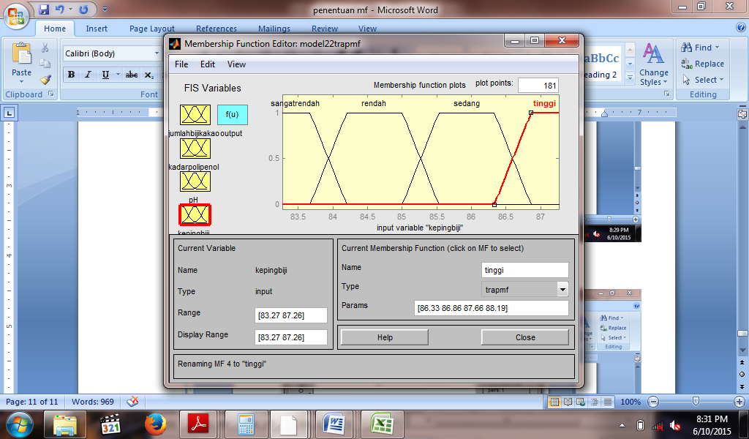
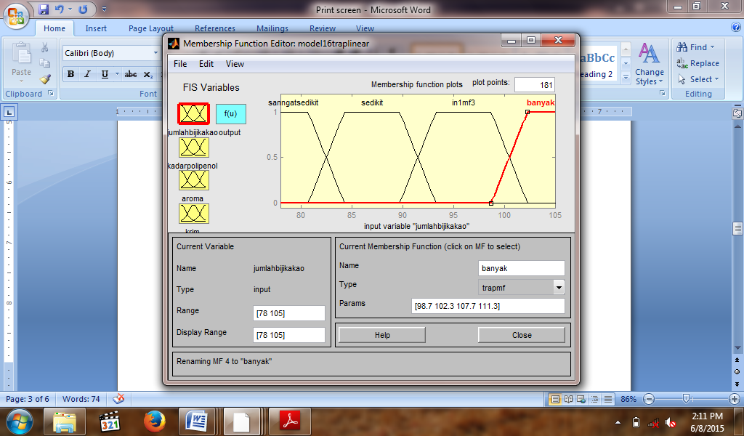
Data on quality of cocoa products is transformed into fuzzy with trapezoid type (Figure 3). Input variables consist of the number of cocoa beans / 100gr, the proportion of cotyledon, poliphenol levels, and pH.

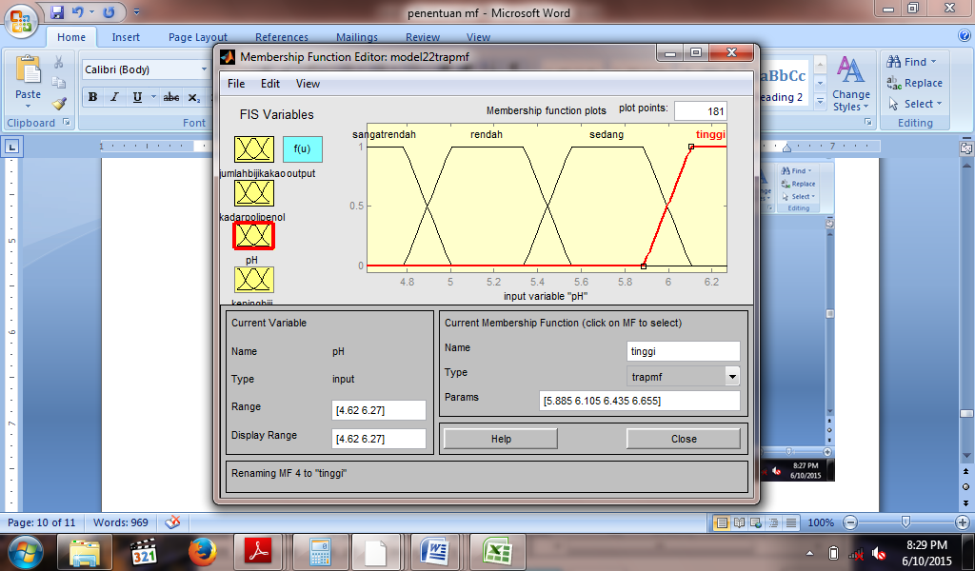
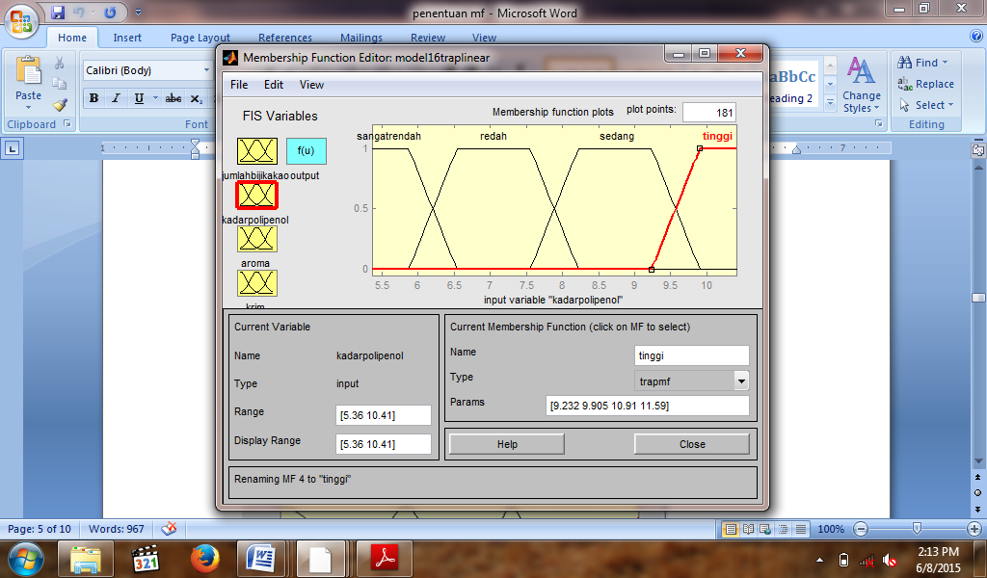

Figure 3: Trapezoidal membership function for r four input variables
After fuzzyfication process, the establishment of the rule if then follows. The number of rules is in accordance with the input variables and parameters. In ANFIS architecture, rules are made adaptively according to the characteristics of training data entered. The number of rules in this study is 256 rules. The following are examples of the if then rules:
Rule 1: If the number of beans is lowandpolyphenol level is lowandpH is moderateandcotyledons are moderate then it is Geumpang (Aceh)
Rule 2: If the number of beans is moderate and polyphenol level is low and pH is moderate andcotyledons are low then it isTiro (Aceh)

3.2 Training and testing

Training is done by using training data for pattern recognition process, as to obtain the best ANFIS model with the smallest average training error. Training and testing process is done by entering data four inputs, namely the number of cocoa beans per 100 g, polyphenol levels, pH, and proportion of cotyledons. Sharing of training data and test data uses the leave one out method. Hybrid learning process uses 100 training epochs, trapezoidal type for input variable and constant for output variable. Training and testing results of ANFIS model can be seen in Figure 4.
Figure 4 shows that the model has been able to recognize training data patterns well, proven by the training error of 7.8807x10⁻⁷. After testing, the model is able to predict the origin of cocoa products with a relatively small error rate of 6.3664x¹⁰⁻⁹.
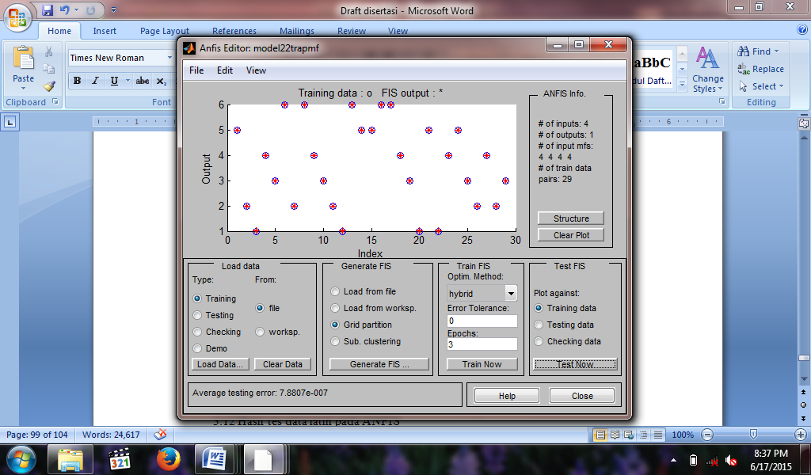
Figure 4 (a): Comparison of the training data with FIS output
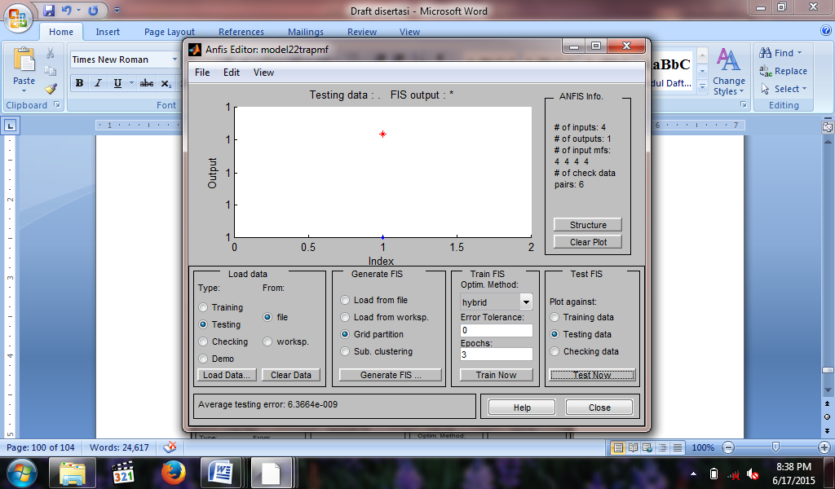
Figure 4 (b): Comparison of the test data with FIS output
Figure 4: Comparison of actual data with the results of ANFIS prediction model
- Validation of the model
Validation of the model aims to determine whether the model developed can be applied to other data. If this model can be applied to other data and generate exact predictions with the smallest error value, then this model can be said to be valid. In the model validation, we need other data different from the data used for modeling. The model validation process uses data checking. Results of the validation model can be seen in Figure 5.
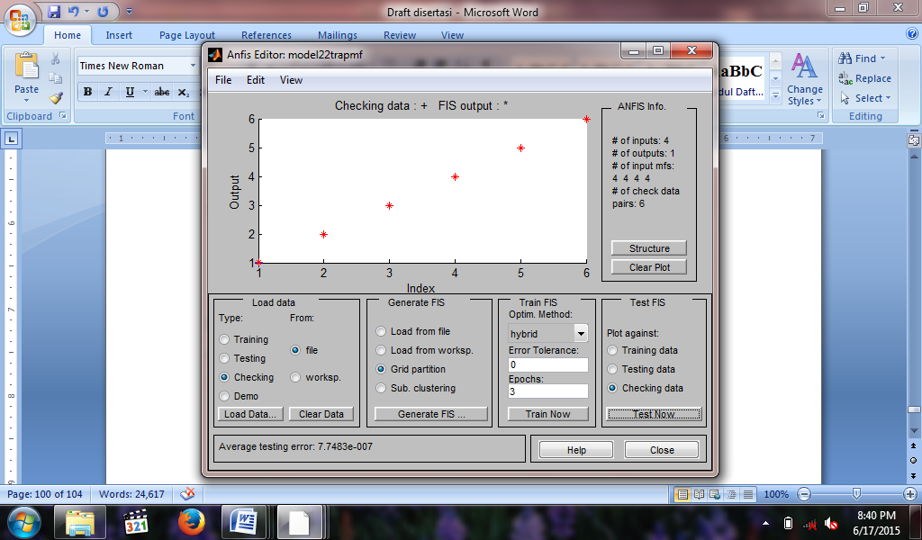
Figure 5: Comparison on the results of predictionmodel with actual data
In Figure 5, it can be seen that the model has been able to prove the geographical authenticity of cocoa products, proven by the accuracy of the model in predicting the area of origin of cacao products with an error rate of 7.7483x¹⁰⁻⁷. Figure 5 also shows a blue star symbol that represents the actual data obtained from the analysis and, the red star symbol that is the result of ANFIS model prediction.
- Conclusion
ANFIS model built has been able to use to prove the geographical authenticity of cacao from Geumpang (Aceh), Padang Tiji (Aceh), Tiro (Aceh), Lampung, East Java, and Sulawesi.
It can be seen from the results of the study showing training error, testing error, and checking error, respectively 7.8807x10⁻⁷, 6.3664x10⁻⁹, and 7.7483x10⁻⁷ .
References
[1] Yusianto. 1998. Analisis hubungan antar komponen citarasa biji kakao. Pelita Perkebunan, 14 (2) : 124-140.
[2] Beckett ST. 2008. The Science of Chocolate. Combride: The Society of Chemistry.
[3] Lima, L.J.R.; M.H. Almeida; M.J.R. Nout& M.H. Zwietering (2011). Theobromacacao L., the food of the Gods: quality determinants of commercial cocoa beans, with particular reference to the impact of fermentation. Critical Reviews in Food Science and Nutrition, 51, 731-761
[4] Misnawi, Jinap S, Jamilah B, Nazamid S. 2004. Sensory properties of cocoa liquor as affected bypolyphenol concentration and duration of roasting. Food Quality and Preference, 15: 403–409.
doi:10.1016/S0950-3293(03)00097-1.
[5] Widyotomo, S. (2008). Teknologi fermentasi dan diversifikasi pulpa kakao menjadi produk yang bermutu dan bernilai tambah. Warta Review Penelitian Kopi dan Kakao, 24, 65-82.Widyotomo, 2008).
[6] Motamayor, J. C., Lachenaud, P., Wallace sa Silva e Mota, J., Loor, R., Kuhn, D. N., Brown, J. S., et al. (2008). Geographic and genetic population differentiation of the Amazonian chocolate tree (Theobroma cacao L).PLoS One, 3(10), e3311. doi:10.1371/journal.pone.0003311.
[7] Pouta E, Heikkilä J, Forsman-Hugg S, Isoniemi M, Mäkelä J. 2010. Consumer choice of broiler meat: The effects of country of origin and production methods. Food Quality and Preference, 21:539–546.
[8] Skoglund T, Dejmek P. 2007. Fuzzy traceability: aprocesssimulationderived extension of thetraceability concept in continuousfood processing. Trans IChemE,Part C.
[9] Cajka T, Riddellova K, Klimankova E, Cerna M, Pudil F, Hajslova J. 2010. Traceability of olive oil based on volatiles pattern and multivariate analysis. Food Chemistry, 121: 282–289.
[10] Marimin, 2009. Sistem Pakar dalam teknologi manajerial: Teori dan aplikasi. Bogor: IPB-Press.
[11] Standar Nasional Indonesia. 2008. BijiKakao. BadanStandarisasi Nasional.
[12] Singleton V.L., Rossi J.A. 1965. Colorimetry of total phenolics with phospholybdic-phosphotungstic acid reagens.Am.J.Enol.Vitic, 16:144-158
[13] Iyatomi H, Hagiwara M. 2004.Adaptive fuzzy inference neural network.On Pattern Recognition Society. 347: 2049-2057.
[14] Jang, J.-S. R, 1993, ANFIS: Adaptive-network-based fuzzy inference sistems, IEEE Trans. on Sistems, Man and Cybernetics, 23(03):665-685.
[15] Duda RO, Hart PE, Stork DG. 2001. Pattern Classification. NewYork.

